PRISM-GAN: a toroidal, palette-conditioned generative adversarial network for tileable apparel pattern synthesis and garment-level visualization
Abstract:
Motifs should be periodic, use a prescribed colour palette and be aesthetically pleasing in apparel pattern design, but generative architectures for fabrics fail to account for these constraints simultaneously. Adversarial GANs generate realistic fabrics but produce patterns which cannot be seamlessly tiled since the edges of patterns will not match up in repeated tiling, provide no way to control the colours produced, and are rarely checked for novelty in the generation of motifs. We introduce PRISM-GAN, a class-conditional GAN architecture where periodicity is built into the architecture: circular padding with integer frequency Fourier inputs make all generated outputs tileable, feature symmetrization in wallpaper groups is used to reveal the periodic nature of patterns as a user-controllable parameter, and seam-discrimination enforces matching across seams in each tiling of the patterns. Conditioning the generator on both palette and fabrics with a chamfer adherence loss on colours provides control over the generated colour scheme, memorization hinge loss is added as protection against pattern copying and the generation of differentiable pattern rendering on garments and corresponding discriminators optimize for patterns on garments. The proposed architecture is trained on 3,781 native resolution 128x128 pattern patches extracted from garment regions of DeepFashion-MultiModal with item-grouped splits and evaluated based on 11 metrics related to fidelity, diversity, memorization, aesthetic appeal, tileability and conditional fidelity. The proposed GAN achieves a seam ratio of 1.034, where 1.0 indicates seams indistinguishable from the interior of the pattern, along with an FID of 81.21, Vendi diversity of 32.13, conditional accuracy of 0.664 and a memorization rate of 0.06%.
Keywords: Apparel patterns, Generative adversarial networks, Tileability, Wallpaper, symmetry, Palette control, Textile design.

1. Introduction
Apparel surface pattern design has attracted growing interest in generative modelling, driven by the demand for motifs that can be produced at the pace at which fashion collections turn over. A printed pattern is not consumed as a single picture: it is repeated across tens of metres of fabric, it must exist in several colourways, and it is judged only once it is cut, draped and worn. These three requirements are structural, not stylistic, and a generator that satisfies none of them produces images rather than textiles.
Two ideas from outside textile generation provide a means of meeting these requirements. Periodic parameterisation, in which a generator operates on the torus so that its output repeats exactly by construction, removes the need for the adversarial objective to discover boundary continuity. Wallpaper symmetry groups, the seventeen plane groups that classify every possible planar repeat, provide a finite and nameable vocabulary for the structure a designer actually specifies. Both notions are standard in the mathematics of ornament and in classical texture synthesis, yet to our best knowledge neither has been used as an architectural constraint within an adversarial generator for apparel pattern design.
While previous research has applied adversarial models to textiles, none has done so as this paper does. He and Tao [1] enhanced a cycle-consistent network with attention and identity losses for cultural textile transfer, but the method transfers style onto existing images and never constrains the output boundaries to join. Ma and Qi [2] coupled conditional generation with reinforcement learning from human feedback so that designers steer aesthetic quality, though the approach requires repeated feedback collection and exposes no attribute a designer can state directly. Chen [3] injected cultural style embeddings into StyleGAN2 with interpretable latent controls, yet the controls remain unlabelled latent directions and the author notes that fidelity metrics do not capture textile-specific structure. Xu et al. [4] adapted StyleGAN3 to high-resolution clothing style generation and editing, and Fan [5] redesigned deep convolutional architectures for fast fashion image synthesis; both evaluate the result as a flat image and neither specifies colour quantitatively. None of these five works constrains the generator to be periodic, none reports any measurement at the tile boundary, none allows a palette to be supplied as input, and none measures how close its samples lie to the training corpus, which matters because the cultural datasets used in [1] and [3] are small and stylistically narrow. This paper makes periodicity architectural, exposes the repeat symmetry group and the colour palette as explicit conditioning inputs, adds a memorisation hinge calibrated against unseen real fabric, and optimises patterns through a differentiable drape renderer on real garments.
Objectives
- Construct an apparel-native pattern corpus by extracting native-resolution patches from garment regions, with an audited filter that retains only all-over repeat prints and item-grouped splits that prevent leakage between views of the same garment.
- Make exact tileability a property of the generator rather than of the loss, using circular-padded synthesis with integer-frequency Fourier inputs, wallpaper-group feature symmetrisation and seam-aware discrimination.
- Supply the generator with a designer-facing specification, namely the pattern class, the fabric type, the repeat symmetry group and a five-colour CIELAB palette, enforced by an explicit colour-adherence objective.
- Compare the framework against state-of-the-art generative models and an incremental ablation ladder under an identical eleven-metric protocol spanning fidelity, coverage, diversity, novelty, aesthetic quality, tileability and conditional fidelity.
Aim
The aim of this research is the generation of apparel surface patterns that are directly usable in textile production rather than merely viewable as images. Instead of leaving repeat structure and colour to emerge from adversarial training, this framework builds periodicity into the synthesis path and accepts the repeat symmetry and the palette as stated inputs. During training, the pattern is additionally rendered onto real garment photographs through a differentiable drape operator, so that it is optimised in the condition in which it will finally be judged. The framework also reports how close its samples lie to the training corpus, rather than assuming novelty.
Novelty
This paper stands out in the sense that it integrates three ideas that have not been combined before in apparel pattern generation. First, exact tileability is obtained architecturally rather than through loss weighting, and is verified by a seam ratio that separates the proposed framework from every comparison and ablation configuration by a wide margin. Second, the repeat symmetry group and the colour palette are introduced as explicit conditioning inputs, making the pattern space navigable by attributes a designer names rather than by unlabelled latent directions. Third, a garment-context discriminator optimises the pattern on a draped and shaded garment, which none of the reviewed frameworks does. An incremental ablation ladder identifies which of these contributes what, including the finding that the memorisation hinge is a safeguard that costs nothing because the measured memorisation rate was already negligible without it.
Contribution
- A reproducible apparel-pattern dataset construction pipeline that extracts 3,781 native-resolution 128 × 128 patches from garment regions of DeepFashion-MultiModal, with an audited repeat-versus-placed print filter and item-grouped splits validated against near-duplicate leakage.
- A toroidal generative architecture combining circular-padded synthesis, integer-frequency Fourier inputs, wallpaper-group feature symmetrisation and seam-aware discrimination, making every generated pattern exactly tileable while keeping the repeat group under user control.
- A palette- and fabric-conditioned generator with a Chamfer colour-adherence objective in CIELAB space, providing explicit designer control over the colour scheme of the synthesised pattern.
- A differentiable drape renderer and garment-context discriminator that evaluate and optimise patterns as they appear on real garment photographs, together with an eleven-metric protocol applied identically to every configuration reported.
2. Literature Survey
The authors Luo et al. [6] (2025) have proposed a pattern design architecture based on CNN for cheongsam generation, using GAN generation and user feedback. Using the architecture on 1,000 images and asking 828 people to score them, they found a visual beauty rating of 4.2/5, cultural inheritance of 3.9/5 and modern innovation of 4.0/5. But the rating is purely subjective, the training set is very small, and user feedback is gathered after generation. The authors' work will use an aesthetic predictor trained on AVA and independent of the training objective, combined with an aesthetic reward, ensuring the quality is optimised and assessed separately. The authors Alfarano and Postma [7] (2024) have proposed ColorwAI, which uses ShapleyVec for disentangling colour from pattern on StyleGAN2-ADA and diffusion model to allow designer-led colour exploration while keeping the structure intact. Validation is done with expert questionnaire alone, the variance in structure is low on purpose, and the method is meant for recolouring rather than for generation of new patterns. The authors' work will generate structure and colour at once: five dominant CIELAB colours and coverage weights for them form a conditioning vector which will be enforced with Chamfer colour-adherence loss, so the colour will be specified rather than explored afterwards, while structure will be generated anew for every sample.
The authors Zhang et al. [8] (2026) have proposed DO-GAN, which disentangles content from style, imposing orthogonality constraints on the style codebook to allow the designer to manipulate culturally meaningful primitives independently. There are no quantitative results available in the papers, the disentanglement quality depends on the dataset used, and the control primitives are unlabelled codes rather than named attributes. The authors' work will not depend on emergent properties but will condition on the named attributes provided by the designer: one of six wallpaper point groups, a palette and a fabric type, with conditional fidelity measured at 0.664 by independent feature-space probe. The authors Meng et al. [9] (2025) have constructed a structured Yi motif database through manual curation and semantic annotation, followed by adversarial training. The trade-off between authenticity and novelty is assessed subjectively, and the scarcity of the heritage limits the dataset size. The authors' work will quantify the trade-off, reporting distributional fidelity, coverage, diversity and memorisation from the same sample set.
The authors Bhattacharjee et al. [10] (2025) have proposed NeuralLoom, a handloom design dataset and framework evaluated by user scores; the authors admit that the area is immature with no established evaluation protocol and no controllable generation mechanism is presented. The authors' work will contribute a fixed eleven-metric protocol applied consistently to every configuration, including the ablation ladder. The authors Ghasemi et al. [11] (2024) have proposed DCG-GAN for early-stage design ideation, which is evaluated for realism, novelty and diversity, but it is found that generated and style-mixed samples remain close to the training distribution, limiting novelty, and the system is not apparel-specific. The authors' work will treat novelty as a constraint, adding a memorisation hinge in a frozen feature space which penalises any sample closer to the training set than typical unseen real fabric.
The authors Octadion et al. [12] (2025) have proposed a combination of a Diffusion GAN and StyleGAN2-ADA for intricate Batik motifs, evaluated with FID, KID, precision, recall and non-redundancy, but the hybrid adds architectural and computational complexity, and the outputs are flat motifs which are never evaluated on garments. The authors' work will retain a single adversarial generator, which gets its structural guarantee from architecture rather than a second generative process, and evaluate the patterns both flat and draped. The authors Huang and Mo [13] (2025) have introduced SegCycle-SPADE, which combines SegFormer segmentation, CycleGAN generation and SPADE transfer, reporting pixel accuracy 88.6%, mean IoU 78.1%, Boundary F1 73.8%, PSNR 27.8 dB, SSIM 0.89 and FID 34.2 on Batik Nitik 960, Fashion MNIST and DeepFashion. The multi-stage nature of the design is complicated, the FID shows moderate fidelity, and the generic fashion datasets are used along with the craft set. The authors' work will use a single-stage generator and will generate its training data from garment regions directly, with an audited filter which separates all-over repeat prints from placed prints so the training distribution will contain only patterns which can tile.
The authors Scharff et al. [14] (2024) have compared StyleGAN2-ADA and Stable Diffusion on African wax prints, finding that neither of the methods reliably reproduces the symmetry and repetition structure which defines wax prints, on a small dataset. The authors' work will make that structure an integral part of the generator rather than something that adversarial objective must discover, symmetrizing features over a selected wallpaper point group at low resolutions while leaving high-resolution layers unconstrained. The authors Simanjuntak et al. [15] (2024) have generated Ulos motifs in the DiTenun weaving platform, but the dataset is small, no generative metrics are reported and the focus is on platform usability rather than controllable generation. The authors' work will report the full metric set on a held-out, item-disjoint protocol and provide the controls which the platform-based setting does not have.
The authors Zheng et al. [16] (2026) have proposed apparel pattern generation using an improved Pix2Pix with a conditional diffusion repair stage, proving the significance of structural information, but the two-stage pipeline is complicated and slow, Pix2Pix requires paired data, and no aesthetic assessment is provided. The authors' work will require no paired data, will generate patterns from noise under attribute conditioning and will include aesthetic quality in its metrics. The authors Jung et al. [17] (2025) have proposed Deep Fashion Designer, which uses many-to-one translation to synthesize a coherent item from several inputs; the fusion may blur item-specific details, aligned inputs are required and no surface-pattern control is provided. The authors' work will operate at exactly that unaddressed level, synthesizing the surface pattern itself under explicit control.
The authors Salloum et al. [18] (2025) have generated women's clothing in casual, formal, office and outerwear categories, emphasizing the evaluation metrics, but the wide coverage leads to loss of per-category fidelity and no pattern-level control is provided. The authors' work will show per-class behaviour across its four pattern categories under class-balanced sampling, so the performance on the rarest category will remain visible. The authors Kamakshi Thai et al. [19] (2025) have conditioned a GAN on clothing type, colour and texture, but the control is categorical rather than quantitative and dataset details are scarce. The authors' work will condition the GAN on a continuous colour specification, five CIELAB colours with coverage weights, enforced with an explicit adherence loss rather than the conditional discriminator alone. The authors Liu et al. [20] (2024) have proposed a texture CycleGAN for embroidery style migration, which combines style transfer with a Markovian texture model; the extra module adds complexity and cost, unpaired transformation may distort the structure, and no controllable generation is addressed. The authors' work will preserve the structure by design rather than cycle consistency, since the periodic parameterisation constrains the output geometry, and will control generation through named attributes rather than reference style image. Overall, these works prove that adversarial models can capture textile appearance, but none of them constrain the generated pattern to tile exactly, none specify colour as a quantitative input, none measure how close its samples lie to the training data, and none optimize patterns as they appear on a garment, which is the combination the authors' work addresses.
Table 1. Comparison of existing textile, fashion and generative pattern methods with the proposed PRISM-GAN
Ref. (Year) | Application Domain | Technical Approach | Core Contribution | Key Technical Gap w.r.t. Proposed PRISM-GAN
[21] Wu and Li (2024) | Knitted textile design | GAN-based deep learning | Generates novel knitted textile designs for creative fashion. | Qualitative evaluation only; no attribute control or tileability.
[22] Zhou et al. (2025) | Fashion outfit generation | OutfitGAN + semantic alignment | Generates complementary items from a given item and reference masks. | Outfit level, not surface patterns; needs masks; no colour or repeat control.
[23] Zhou et al. (2025) | Batch clothing generation | BC-GAN + contrastive compatibility discriminator | Generates multiple visually compatible clothing items. | Targets item compatibility; no palette, symmetry or tileability constraint.
[24] Guan et al. (2025) | Outfit recommendation | GAN-based collocated clothing synthesis | Generates varied clothing combinations for recommendation. | Diversity measured at outfit level; no pattern-level fidelity, novelty or seam metric.
[25] Cao et al. (2026) | Traditional Li textile arts | SDCS-3D GAN + Cuckoo Search | Reconstructs textile textures preserving colour and weave continuity in 3D. | Reconstruction, not novel generation; no designer-specified attribute control.
[26] Suzuki et al. (2026) | Sewing-pattern generation | Segmentation + part-wise conditional GAN | Generates sewing patterns for bodices, sleeves and collars. | Construction geometry, not surface appearance; depends on upstream segmentation.
[27] Zhu et al. (2024) | Digital textile printing | Pix2Pix GAN | Predicts silk printing colours matching post-production appearance. | Needs paired images; predicts an existing design rather than generating under a palette.
[28] Deng et al. (2026) | Camouflage pattern design | Conditional GAN + K-means + image quilting | Generates environment-conditioned camouflage with seamless expansion. | Seamlessness is post hoc quilting, risking repetition artefacts; concealment, not aesthetics.
[29] Xu et al. (2024) | Fabric defect augmentation | FabricGAN + Double U-Net | Synthesises defect samples via defect-texture fusion. | Augments defects, not patterns; no aesthetic evaluation or attribute control.
[30] Mohammed and Clarke (2024) | Fabric defect augmentation | Conditional GAN + U-Net + PatchGAN | Synthesises defective fabric to address dataset imbalance. | Defect translation from defect-free bases; no creative or controllable synthesis.
[31] ul Huda et al. (2024) | Stitching-defect synthesis | DCGAN | Generates stitching-defect images for limited industrial datasets. | Single defect category, low resolution; no structure, colour or repeat control.
[32] Hu et al. (2025) | Fabric defect restoration | Improved GAN | Restores noisy, blurred defect imagery for inspection. | Restoration, not generation; no motif structure or controllable synthesis.
[33] Qin et al. (2025) | Few-shot defect synthesis | LarGAN + progressive GAN | Generates rare defect samples from extremely limited data. | Single-image training constrains diversity; no motif-level generation control.
[34] Xia et al. (2026) | Textile defect generation | GAN-PD + local feature residual module | Generates elongated fabric defects, improving detection. | Optimised for defect morphology and detectors; no palette, symmetry or seam control.
[35] He et al. (2026) | Multi-class defect synthesis | FLSC-DCCGAN + Laplacian pyramid fusion | Generates and transfers defect samples onto defect-free fabric. | Composites onto existing fabric; controllability is defect class, not design attributes.
PRISM-GAN (proposed) | Apparel surface pattern synthesis | Toroidal wallpaper-symmetric GAN + palette conditioning + novelty hinge + garment-context discriminator | Generates exactly tileable, palette- and symmetry-controllable apparel patterns, optimised and evaluated on real garments. | The system features architectural periodicity achieving a 1.034 seam ratio without post-processing, controlled via named palette, symmetry group, and fabric inputs. It incorporates a memorization hinge capping reproduction at 0.06% and a drape renderer to optimize worn patterns, evaluated across 11 fidelity, diversity, novelty, aesthetic, and tileability metrics.

3. Proposed Methodology
The proposed PRISM-GAN (Periodic, Reward-aligned, Interactive, Style-and-palette Modulated Generative Adversarial Network) framework may be employed for the purpose of synthesising printable apparel surface patterns that are seamlessly repeatable, adhere to a designer-specified colour palette, and still look visually convincing when draped on a garment. Contrary to currently available apparel and textile generation approaches that apply style transfer on existing imagery, collect feedback after the generation process, or view the generated pattern as a standalone flat image, the proposed framework brings the following elements into a unified adversarial architecture: apparel pattern extraction, wallpaper-symmetric toroidal synthesis, palette- and fabric-modulated generation, novelty-constrained adversarial training, and garment context-based optimisation. Firstly, patterned garment regions are detected in full-body fashion photographs using parsing masks, native-resolution pattern patches are extracted from the regions, and selected based on their being all-over repeat prints; then garments are split by identity so that there is no intersection between the training and evaluation sets. Secondly, the input vector to the generator is formed by the pattern class, the wallpaper symmetry group, the fabric type, and five dominant CIELAB colours together with their coverage weights; this is a design-side specification of the pattern that should be synthesised. Thirdly, the generated samples are made exactly periodic by applying the circular-padding-based modulation and integer-frequency Fourier inputs and then reducing resolution to perform group symmetrisation in the Toroidal Synthesis block, while the seam-aware discriminator examines the samples in the toroidal domain to enforce the boundary continuity instead of assuming it. Then the generated pattern is evaluated using a combination of the adversarial loss, the Chamfer colour adherence loss in the CIELAB colour space, the memorisation hinge that penalises samples closer to the training set than unseen real fabrics are, and the anchored aesthetic reward applied in a short finishing phase. To ensure that the pattern is optimised in the context where it is finally judged, the Garment Context module applies the generated tile to a real garment region using a differentiable drape operation consisting of scaling and rotating, toroidal wrapping of coordinates, multiplication by a shading measurement and composition with a photograph; then the composite is judged by the garment context discriminator. The performance of the generator is measured by a protocol of eleven metrics ranging from distributional fidelity and coverage, sample diversity and memorisation to aesthetic quality, tileability and conditional fidelity, all of which are calculated against the holdout set of real samples under identical evaluation procedure for all configurations. The pipeline of the proposed PRISM-GAN framework is shown in Figure 1 below.
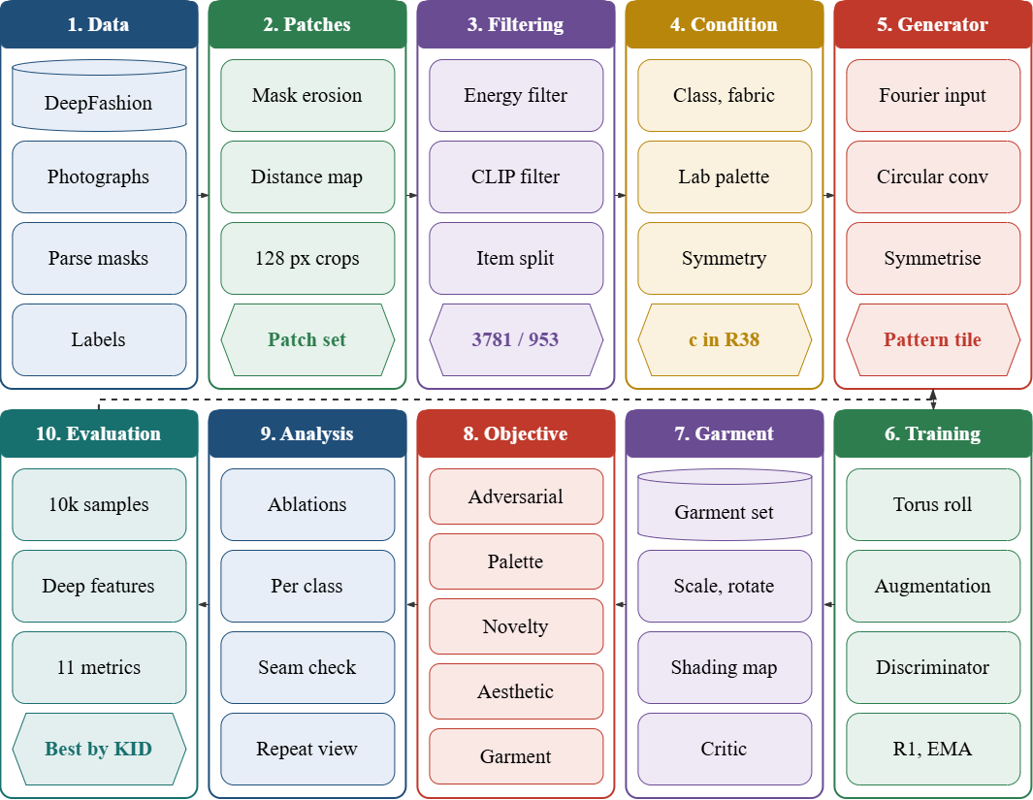
Figure 1. Overall workflow of the proposed PRISM-GAN framework.

3.1 Dataset Description
As the primary data resource for the development and testing of the proposed PRISM-GAN framework, DeepFashion-MultiModal dataset is selected due to its availability of high-resolution pictures of clothes along with the corresponding human parsing masks and labels for individual attributes, thus enabling isolation of fabric surface patterns in real clothing instead of working with whole garments. In contrast to cultural heritage pattern datasets of a few hundreds of curated flat patterns, the selected dataset includes 44,096 images at the resolution of 750×1101, of which 12,701 images contain manually annotated parsing labels over 24 semantic classes, along with annotations for pattern and fabric in the upper, lower and outer garment of every image and per-image descriptions, thus allowing the proposed framework to learn the appearance of pattern native to apparel while retaining the garment context necessary for the drape rendering module. Pattern annotation includes categories of floral, graphic, striped, lattice, colour-block, pure-colour and "other", while fabric annotation includes denim, cotton, leather, furry, knitted and chiffon. The colour-block and pure-colour images are excluded from consideration as within a square patch of those images there is no repeating motif, while the "other" category is excluded as it represents plain knit and heather fabrics rather than designed patterns, thus floral, graphic, striped and lattice remain the four classes for generation. The dataset can be accessed through https://github.com/yumingj/deepfashion-multimodal.
Before developing the model, the annotated images are processed into pattern patches using a reproducible extraction pipeline preserving the relation of every patch to the garment it belongs to. For every patterned garment, the corresponding parsing region is eroded by 6 pixels to get away from seams, hems and silhouette edges, and the chessboard distance transform is used to detect every location in which a 128×128 window is completely within the eroded region. Up to four windows are sampled per garment with minimum center separation of 64 pixels, and all crops are performed at the native resolution without rescaling, as only 57 garments of the corpus admit a native 256-pixel patch, while 4,162 admit a 128-pixel patch. Extraction yields 8,122 candidate windows that are subsequently filtered in two steps. Using the texture energy threshold of the third percentile of the floral, striped and lattice distributions removes flat, blurred or effectively plain crops. For the graphic category, the CLIP ViT-L/14 zero-shot score distinguishing all-over repeats from placed prints is applied alongside the texture energy threshold, as the placement of text and logo prints does not allow tiling and would contradict the periodic generator; the criterion is established during the manual audit of 200 crops of the graphics class and provides a precision of 0.90 at a recall of 0.648, with 62.5% of the audited samples being true repeats. Both filters remove 3,388 windows, including 2,571 placed prints, 761 flat crops and 56 windows belonging to garments of which windows are mainly placed prints.
The remaining 4,734 windows are divided into training and test subsets based on garment identities rather than images, as the source corpus includes several photos of the same garment and the image-based division would place different views of one fabric on either side of the division. The splitting is stratified by the pattern class over garment identities. An additional check for near-duplicates is performed, in which every test window is compared to the training set in CLIP embedding space, and any test garment whose nearest training neighbor exceeds a cosine similarity of 0.98 is added to the training subset; the threshold was determined visually by examining potential pairs across different similarity bands, and showed that the pairs below 0.98 are only similar patterns while those at 0.98 and above are the same fabric but under different garment identifiers. This check results in adding three garments to the training subset. No validation subset is created, as checkpoint selection in the adversarial training is done against the training distribution and not against a held-out subset, and dividing a dataset in three partitions would reduce the already small test set. Partitioning of the dataset for experimental study is shown in Table 2.
Table 2. Dataset partitioning for PRISM-GAN
Dataset split | Garment items | Patches (samples) | Split %
Training set | 1,169 | 3,781 | 79.87 %
Test set | 289 | 953 | 20.13 %
Total | 1,458 | 4,734 | 100 %
The training set is used for the adversarial training of the generator and the discriminators, and the features of the training set are used as a reference distribution for calculating fidelity, coverage and diversity metrics. The test set is used for two different objectives: first, for the calibration of the memorization threshold, based on the proximity of a truly unseen real sample to the training set; and second, as the real data reference row for interpreting the generated samples. The same subsets are used for both the proposed approach and each ablation setup in order to provide an apples-to-apples comparison. The class composition of the two subsets is provided in Table 3.
Table 3. Class composition of the training and test subsets
Pattern class | Training patches | Test patches | Test share
Floral | 664 | 193 | 22.5 %
Graphic (repeat prints) | 1,896 | 435 | 18.7 %
Lattice | 295 | 87 | 22.8 %
Striped | 926 | 238 | 20.4 %
Total | 3,781 | 953 | 20.1 %
Due to the unbalance of the classes with the ratio 6.4 of the number of graphics over the number of lattice, sampling weight for the generation of the minibatches is inversely proportional to the square root of the class frequency, and the conditioning labels of the generated samples are sampled from the same resulting prior such that the discriminator sees the same label distribution of real and generated samples. Together with the pattern corpus, garment bank of 1,500 crops is built from the same set of images for the drape-rendering module limited to patterned garments of the training samples such that no test garment would appear at any step. For each item, the garment area is cropped into a square bounding the parsing mask and resized together with the binary mask to 128×128, and shading map is calculated as the ratio of the luminance channel to the Gaussian blurred version of it with the values from 0.4 to 1.8 clipping, which allows to separate the local folds and lighting from the underlying pattern. With the help of these three tensors, a generated tile can be tiled over the garment area, shaded with the calculated shading, and compositing onto the original image, which allows to test the garment-context discriminator in the condition where the pattern will appear.
Each patch also carries the conditioning attributes used by the generator. Pattern class and fabric type are simply transferred from the source annotation, while the color palette is calculated for each patch as the five clusters k-means in the CIELAB space with the retention of the cluster centers and the coverage weights sorted by the coverage. On the sample of the corpus, the extracted palettes have a good internal separation with the median distance of 22 to 36 ΔE between the colors, but the weighted chroma is very low, between 2.6 and 9.3, depending on the class. This is due to the predominantly dull colors of the commercial fashion photographs. Therefore, palette-adherence evaluation is performed with palettes sampled from the data distribution rather than with the saturated palettes, which the generator was never trained to reproduce. Thus, the constructed corpus provides pattern appearance native to the apparels, garment-level rendering context and conditioning attributes required for the PRISM-GAN framework, and item-grouped partitioning provides the generalization to the unseen garments.

3.2 Data Pre-processing
The process of developing the proposed PRISM-GAN framework begins with the systematic preprocessing of the DeepFashion-MultiModal dataset in order to yield standardised and leak-proof patches along with their corresponding attributes. This is because the proposed framework consists of toroidal pattern synthesis, palette conditioned generation and garment context based optimisation and hence, the preprocessing step involves garment region localization, patch extraction, repeat print filtering, attribute creation, grouping of identities and leak prevention. The underlying motivation for preprocessing is to retain the texture of real fabric patches such that the generator is never exposed to patterns which cannot properly tile or garments that have already been seen during the training phase. Let the complete set of labeled garments be denoted by
$D=\{\left(I_{i},M_{i},y_{i},f_{i},g_{i}\right)\}_{i=1}^{N}$ (1)
where N = 12,701 is the number of full-body images with manual parsing annotations, $I_{i}$ is the garment image, $M_{i}$ is the parsing mask with respect to 24 semantic classes, $y_{i}$ is the pattern class of the manually annotated garment, $f_{i}$ is the fabric class of the garment and $g_{i}$ is the garment ID under which the image is stored. Every garment slot, either upper, lower or outer garment, is considered as an individual record, since the same photograph can include multiple independent annotations. Pattern records with the label of pure colour, colour block or other are omitted, as there is no repeating pattern in a square crop. Hence, the available patterns for synthesis are only the floral, graphic, striped and lattice patterns. The patch extraction is performed from the parsing mask, not the whole image, so that all the training samples would be of a fabric class. First, the binary region $R_{i}$, associated with the annotated slot, is eroded with a margin of m = 6 pixels in order to be away from seams, hems and silhouette boundaries, and then the admissible centers of the windows are computed using the Chebyshev distance transform of the eroded region,
$Ω_{i}=\left\{\left(u,v\right) | D_{∞}\left(ε_{m}\left(R_{i}\right)\right)\left(u,v\right) ≥ \frac{p}{2}+1\right\}$ (2)
where $ε_{m}$ is the morphological erosion by m pixels, $D_{∞}$ is the chessboard distance transform, and p = 128 is the patch side. The centre meeting this criterion ensures that the entire $p × p$ window is inside the garment region, so there will be no background, skin, and other garments in the crop. No more than four centers are selected per record with a minimum Chebyshev distance of 64 pixels for reduced overlapping, and no resizing takes place because only 57 garments allow for a 256-pixel native window while 4,162 allow for a 128-pixel native window. This results in 8,122 candidate patches. Because the placed prints like slogans and logos do not allow for tiling and hence violate the idea of a periodic generator, the patches are filtered out prior to training. Two scalar values are calculated for each patch: texture energy e_{k} which is defined as the standard deviation of high-pass luminance (obtained by subtracting the Gaussian blurred version of the patch), which identifies smooth and blurred patches, and CLIP zero-shot repeat probability $π_{k}$ calculated using a frozen ViT-L/14 encoder as
πk=σ​log​t∈Prep​e sk,t-log​t∈Pplc​e sk,t (3)
where $s\left(k,t\right)$ is the normalized cosine similarity between the patch embedding and the embedding of text prompt t, $P_{rep}$ is the set of prompts representing all-over repeating fabric patterns, $P_{plc}$ is the set representing printed text, logos and single large graphics, and $σ$ is the logistic function. Patch k is kept if e_{k} ≥ e_{min} and, for the graphic class, if also $π_{k}$ ≥ $τ_{π}$. The thresholds e_{min} = 29.03 and $τ_{π}$ = 0.90 were determined from manual inspection of 200 randomly sampled graphic patches by optimizing the F₁ score under a constraint of minimum precision equal to 0.90, producing an audited precision of 0.900 and recall of 0.648 with a measured repeat-print rate of 62.5% in the audited sample. A garment classified as graphic is thrown away if most of its windows do not pass the criterion. This filtering operation discards 3,388 patches, which include 2,571 placed prints, 761 flat crops and 56 patches from predominantly placed-print garments, leaving 4,734 patches that pass the filter. Each surviving patch is then paired with the attributes to be conditioned upon in generation. Pattern class and fabric type are retrieved from the source annotation and represented as one-hot vectors, and the colour specification is derived using k-means clustering of patch pixels in CIELAB space with $K=5$ clusters, retaining the centroids $\{c_{1},…,c_{K}\}$ and coverage weights $\{w_{1},…,w_{K}\}$ sorted in order of decreasing coverage. Lightness is scaled down to 0–1 range by dividing through by 100 and two chromatic components by 128. The final conditioning vector fed into the generator is
$c=\left[ 1_{y} ‖ 1_{γ} ‖ 1_{f} ‖ \left({\tilde{c}}_{1},w_{1},…,{\tilde{c}}_{K},w_{K}\right)\right]∈R^{38}$ (4)
where $1_{y}∈\{0,1\}^{4}$ denotes the class of pattern, $1_{γ}∈\{0,1\}^{6}$ denotes the wallpaper point group desired for the repetition, $1_{f}∈\{0,1\}^{8}$ denotes the fabric category, and the last 20 dimensions contain the normalized color palette. The symmetry group is a generator-only control variable, since photographic images have no annotations for their symmetries; hence the discriminator sees the group-omitted portion of c, which consists of 32 dimensions, whereas the generator sees all 38. The patches that are kept are divided into training and testing sets on a garment ID basis, not on the image, since the dataset has several images of the same garment and the image-based split would put views of one fabric on both sides of the divide. The split is stratified by pattern class on garment ID, in an 80/20 split. Then, residual leaks are prevented by near-duplicate filtering in CLIP embedding space: the garment in the test set is reassigned to the training set if
$\max_{j∈S_{train}} \frac{ϕ{\left(x_{k}\right)}^{​⊤}ϕ\left(x_{j}\right)}{∥ϕ\left(x_{k}\right)∥ ∥ϕ\left(x_{j}\right)∥} ≥ τ_{d}, τ_{d}=0.98$ (5)
where $ϕ\left(⋅\right)$ is the frozen CLIP ViT-B/32 image encoder and $x_{k}$ iterates over the patches of the candidate test garment. The threshold value was manually set based on visual examination of candidate pairs within different similarity bands, showing that pairs below 0.98 are similar patterns of the same type, but pairs above are identical fabric samples cataloged under different garment types, and the condition has reclassified three garments. No validation subset is used, as checkpoint selection is done against the training distribution during adversarial training, not a separate subset. Since the number of classes is unequal, the minibatches are sampled with probabilities inversely proportional to the square root of the number of samples in each class, and the generator’s class labels are sampled from the resulting class prior, ensuring that the discriminator sees consistent label distribution in both real and generated data. Patches are loaded as 8-bit tensors and normalized to the $\left[-1,1\right]$ range, matching the default normalization of generator’s output without hyperbolic tangent and the expected input range of the augmentations pipeline. Also, garment bank used by the drape rendering module is composed of training garments only, each entry consisting of a square crop of size $128 × 128$ along with a binary mask and the shading map given by the ratio of the luminance channel to itself blurred with Gaussian filter, rescaled to the $\left[0.4,1.8\right]$ interval, which separates the folds and light from the pattern. So, the final preprocessing procedure results in obtaining native resolution, filtered and leakage control apparel pattern patches along with conditioning variables for each class, fabric, palette, and symmetry. Thus, the obtained representation gives the required foundation for training and evaluation of PRISM-GAN in flat-pattern and garment-level settings.

3.3 Feature Extraction
In the suggested PRISM-GAN framework, the procedure of feature extraction is aimed at extracting an appearance-based representation of the fabric surface, its colour characteristics, and its repeating patterns. Unlike common approaches to generating images, conditioning the image generation solely on the class label, the proposed approach takes into account both the annotation-based attributes and the calculated colour statistics based on the image patches' pixel values. This provides the generator with the information about the specific pattern that needs to be created and the pattern's symmetry. At the initial stage of the procedure, the set of preprocessed image patches is split into three categories of descriptors, namely annotation attributes, measured colour descriptors, and symmetry control descriptors. The annotation vector for the patch $k$ is represented as
$a_{k}=\left[1_{y_{k}}, 1_{f_{k}}\right], y_{k}∈Y, f_{k}∈F$ (6)
where $1_{y_{k}}∈\{0,1\}^{4}$ is the one-hot encoding of the pattern category in the set $Y=floral,graphic,lattice,$, and $1_{f_{k}}∈\{0,1\}^{8}$ is the one-hot encoding of the fabric category in the set $F=denim,cotton,leather,furry,knitted,chiffon,other,$. In order to describe the colour mixture apart from the categorical description, the palette features are acquired through unsupervised decomposition of the patch in a perceptually uniform colour space. The colour descriptor is given by
Pk={cj,wj}j=1K, cj=Lj*,aj*,bj*, wj=1Πkπ∈Πk​1​κπ=j (7)
where $c_{j}$ represents the $j$-th cluster centre found using k-means clustering of the CIELAB pixel values (K=5), $κ\left(pi\right)$ denotes the cluster membership of the pixel $π\$, \$Π_k$ denotes the pixel collection in the patch, and $w_j$ denotes the coverage weight of the $j$-th colour, arranged in order of decreasing $w_j$. Such feature representation makes it possible for the machine learning model to identify the dominant colours of the fabric and their proportions, without colour being an emergent property of the latent code. The repeat structure of the pattern can be represented using a symmetry control inspired by the plane point groups. The symmetry vector could be
$γ_{k}=1_{g_{k}}, g_{k}∈G=\{p1, p2, p4, pm, pmm, p4m\}$ (8)
such that each element of $G$ specifies the rotations and reflections over which the low-level features extracted from the generated tile are averaged. Thus, the full feature vector provided to the generator is represented as
$c_{k}=\left[{\tilde{a}}_{k}, γ_{k}, {\tilde{P}}_{k}\right]∈R^{38}, {\tilde{c}}_{j}=\left[\frac{L_{j}^{*}}{100},\frac{a_{j}^{*}}{128},\frac{b_{j}^{*}}{128}\right]$ (9)
where $P_{k}$represents the scaled palette features collapsed to 20 components and $a_{k}$the combined annotations encodings. The combination of all three gives the design specification for the PRISM-GAN model, where the generator considers the family pattern, fabric characteristics, colours, and repeat symmetry while generating a tile. Real images do not have any symmetry annotations, making $γ_{k}$ the control input for the generator side alone and the discriminator takes as input the group-free 32 component portion of $c_{k}$. The features derived from this are fed to the toroidal wallpaper symmetric generator.
3.4 Proposed Framework Architecture
The proposed PRISM-GAN framework (Periodic, Reward-aligned, Interactive, Style-and-palette Modulated Generative Adversarial Network) is proposed to serve as an integrated adversarial framework for the synthesis of printable apparel surface patterns under designer-specified colour, fabric and repeat-symmetry requirements. The framework differs from existing approaches in terms of architectural periodicity, wallpaper-group symmetry control, explicit palette conditioning, novelty-constrained learning and garment-context optimisation. The architecture of the proposed framework is shown in Figure 2.
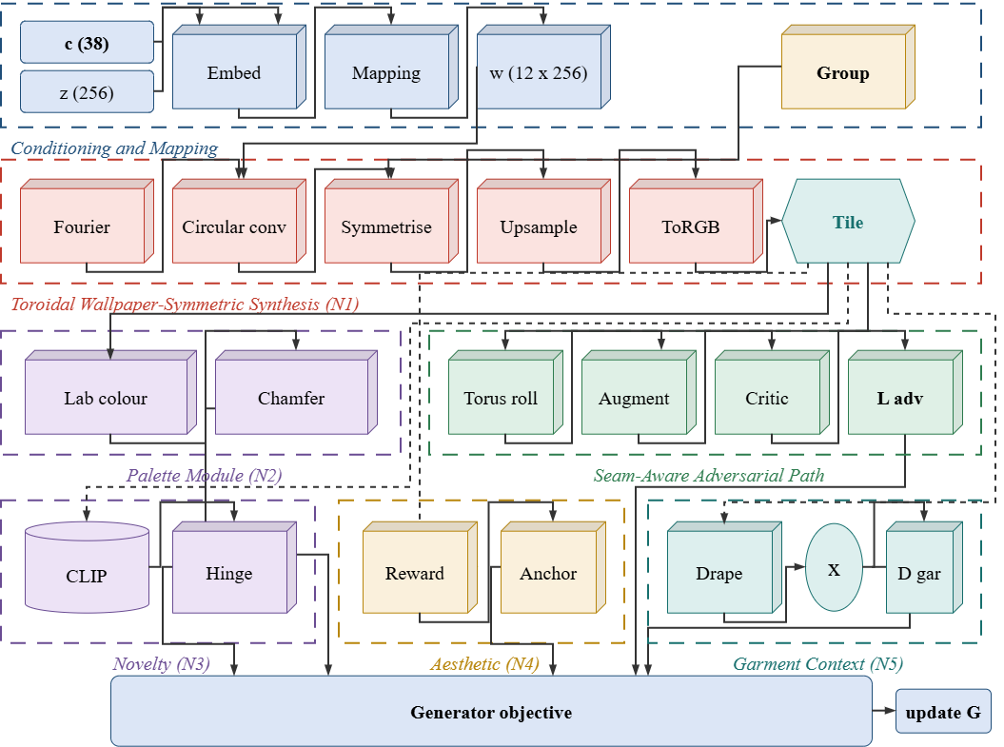
Figure 2. Overall architecture of the proposed PRISM-GAN.
Conditioning vector constructed in Feature extraction stage is processed in a mapping network that outputs style vectors for use in the generator at all twelve synthesis inputs, while four-dimensional class encoding, eight-dimensional fabric encoding and twenty-dimensional palette encoding are input to the network collectively so that the effects of colour and fabric manifest in each resolution of the synthesis. Latent noise is standardised to unit variance and concatenated with normalised conditioning embedding prior to the mapping layers; style mixing is applied with probability 0.9 during training so that no single style vector controls all resolutions. The first key module in our design is Toroidal Wallpaper-Symmetric Synthesis (N1). Unlike the conventional style-based generators, the synthesis starts with integer-frequency Fourier features evaluated on a 4×4 torus, which are periodic by construction. All modulated convolutions in the synthesis path utilise circular rather than zero padding, and all two-fold upsamplings are implemented by circular padding, interpolation and cropping of the feature map, so that periodicity is maintained throughout all six resolution stages. In resolutions below 32 pixels, the feature map is average-pooled over the transformations of the wallpaper point group indicated in the conditioning vector, and is blended with the un-symmetrised features by a per-block learnable strength, so that the requested repeat symmetry is imposed on the layout of the global motif, but the two highest resolutions remain free to introduce irregular fine-grain texture. The produced tile is thus exactly periodic: its left and right edges, and its top and bottom edges, continue one another rather than form independent boundaries.
Generated tile is fed into Palette-Conditioned Colour Module (N2) where the colour constraints indicated by the designer are enforced. The tile is converted from generator's output space to CIELAB via differentiable colour transform, downsampled, and compared with five requested palette colours using two-sided Chamfer distance, so that every generated pixel is required to be close to one of the requested colours and vice versa. This way, the colour becomes a stated constraint on the output instead of an emergent property of the latent code, allowing the same motif to be released in different colourways simply by changing the conditioning vector. Adversarial loss is provided by the projection discriminator operating on the group-free portion of the conditioning vector, since the real images do not contain symmetry annotation. Prior to entering the discriminator, generated tiles undergo random roll on the torus – this is the Seam-Aware Discrimination technique: if the generated tile does not have a proper seam, then rolling results in visible discontinuity, hence the generator is penalised for any seam in its output. Real and generated images additionally pass through an adaptive augmentation pipeline whose strength is determined based on the sign statistics of the discriminator; additionally, lazily applied gradient penalty regularises the discriminator on augmented real data.
There are two additional modules that control the generator's behavior rather than its output appearance. Novelty Constraint Module (N3) uses a frozen CLIP encoder to embed the generated tile and penalise any sample whose nearest neighbor in the training set lies closer than a particular threshold that is tuned from the test split, so that the generator is discouraged from reproducing the training fabrics. Anchored Aesthetic Alignment Module (N4) is activated only in the last tenth of training; it combines frozen pretrained aesthetic reward with a quadratic anchor for the pre-alignment generator, so that the improvement in aesthetics can not be achieved by diverging from the learned distribution. Finally, there is the Garment-Context Module (N5). Generated tile is tiled across a real garment region using a differentiable drape operator that applies random scale and rotation, wraps sampling coordinates on the torus to maintain seamlessness of the tiling regardless of the transformation, and multiplies the result by a measured shading map and composites inside the parsing mask of the garment image. Class-conditional discriminator evaluates such composites against real patterned garment crops, hence the pattern is optimised in its ultimate viewing context. The layer-wise configuration of the framework is presented in Table 4.
Table 4. Layer-wise architecture summary of the proposed PRISM-GAN
Layer | Configuration | Output shape
Conditioning input | 38 features (4 class + 6 symmetry group + 8 fabric + 20 palette) | (38)
Latent input | Gaussian noise, second-moment normalised | (256)
Conditioning embedding | EqLinear (38 → 256) + second-moment norm | (256)
Mapping network | EqLinear (512 → 256) → LReLU → EqLinear (256 → 256) → LReLU | (256)
Style broadcast | Replicate to per-layer styles, style mixing p = 0.9 | (12, 256)
Fourier input (N1) | Integer-frequency cosine features on the 4×4 torus | (256, 4, 4)
Block 4² (N1) | Circular ModConv (256 → 256) + noise + bias + LReLU | (256, 4, 4)
Symmetrisation 4² (N1) | Group averaging over γ, blended by learnable α | (256, 4, 4)
Block 8² (N1) | Periodic 2× upsample → ModConv (256 → 256) → ModConv (256 → 256) | (256, 8, 8)
Block 16² (N1) | Periodic 2× upsample → 2 × ModConv (256 → 256) | (256, 16, 16)
Block 32² (N1) | Periodic 2× upsample → 2 × ModConv (256 → 256) | (256, 32, 32)
Symmetrisation 8²–32² (N1) | Group averaging applied at every resolution ≤ 32 | (256, r, r)
Block 64² (N1) | Periodic 2× upsample → ModConv (256 → 128) → ModConv (128 → 128) | (128, 64, 64)
Block 128² (N1) | Periodic 2× upsample → ModConv (128 → 64) → ModConv (64 → 64) | (64, 128, 128)
ToRGB skips (N1) | 1×1 ModConv per block + periodic upsample accumulation | (3, 128, 128)
Generated tile | Exactly periodic pattern tile | (3, 128, 128)
Palette loss (N2) | RGB → CIELAB → area-pool 32² → two-sided Chamfer to 5 palette colours | scalar
Seam-aware roll | Random cyclic shift on both spatial axes (generated only) | (3, 128, 128)
ADA augmentation | Blit + geometric + colour pipeline, adaptive p | (3, 128, 128)
D FromRGB | EqConv 1×1 (3 → 64) + LReLU | (64, 128, 128)
D residual blocks | 5 × [EqConv 3×3 ×2 + 1×1 skip + avg-pool 2]: 64→128→256→256→256→256 | (256, 4, 4)
Minibatch stddev | Group size 4, one appended channel | (257, 4, 4)
D epilogue | EqConv 3×3 (257 → 256) → flatten → EqLinear (4096 → 256) → EqLinear (256 → 256) | (256)
D conditioning map | EqLinear (32 → 256) + 2 mapping layers (256 → 256) | (256)
D output | Projection: ⟨feature, cmap⟩ / √256 | (1)
Novelty hinge (N3) | Frozen CLIP ViT-B/32 → cosine NN vs. 3,781 training embeddings → hinge at τ | scalar
Aesthetic reward (N4) | Frozen aesthetic predictor + quadratic anchor to Gₒ (epochs 180–200) | scalar
Drape renderer (N5) | Random scale (0.6–1.6) + rotation → torus-wrapped grid sample → × shading → composite | (3, 128, 128)
Garment discriminator (N5) | Same topology as D with channel cap 128, 4-class projection conditioning | (1)
Generator output | Tileable apparel pattern tile, repeatable to arbitrary canvas size | (3, 128, 128)
The suggested design also allows comparing different configuration schemes and doing component-wise ablation. The proposed PRISM-GAN approach is compared against the selected state-of-the-art methods for generative models. Component-wise ablation is carried out using the same data split and evaluation technique. It becomes possible to determine the impact that toroidal wallpaper-symmetric synthesis, palette conditioning, novelty requirement, aesthetic anchoring, and garment context have individually on the resulting design. Hence, the complete architecture makes it possible to consider all of these features at once: structural periodicity, colors, novelty, aesthetics and garment appearance. Parameter distribution of the proposed PRISM-GAN is presented in Table 5.
Table 5. Parameter distribution of the proposed PRISM-GAN
Component | Parameters
Mapping network + conditioning embedding | 207,104
Fourier input + symmetry blend weights (N1) | 262
Synthesis blocks, circular ModConv (N1) | 5,292,491
ToRGB skip connections (N1) | 316,178
Generator subtotal | 5,816,035
Discriminator residual trunk | 4,331,584
Discriminator epilogue (conv + dense) | 1,707,008
Discriminator conditioning map | 140,032
Discriminator subtotal | 6,178,880
Garment-context discriminator (N5) | 1,942,336
Total trainable | 13,937,251
The architecture overview in Table 4 demonstrates clearly that the proposed PRISM-GAN framework architecture is modular and incorporates components, each addressing one limitation of existing textile pattern generation techniques. The toroidal wallpaper-symmetric synthesis brings in printable repeat into the generator rather than relying on it as an adversarial objective, and the palette conditioning enables specifying the color palette directly. Novelty constraint ensures that apparent fidelity could not be achieved through close reproduction of the training dataset. The anchored aesthetic alignment improves the quality of images generated while ensuring that the generator does not stray from the learned distribution, and the garment context module ensures that the pattern is held accountable for its appearance when draped. Consequently, the proposed PRISM-GAN framework architecture represents a step forward in apparel pattern synthesis from flat image generation into a production-focused design process. It becomes possible within the architecture to have the learned generator make decisions regarding the way the motif should repeat, the colors it should occupy, how similar it can look compared to the existing fabrics, and how it would look like once draped, while remaining perfectly tileable at each sample.

3.5 Loss Function and Hyperparameter Configuration
The optimisation approach used in the proposed PRISM-GAN framework is a critical factor in training a generator that is simultaneously realistic, exactly tileable, colour-obedient and non-reproductive on the limited apparel-pattern corpus extracted from DeepFashion-MultiModal. Since pattern synthesis is formulated as class- and attribute-conditional adversarial generation, a style-based generator is trained against a projection discriminator using the non-saturating logistic objective with lazy gradient regularisation, and four auxiliary objectives are attached to the generator to enforce the properties that the adversarial term alone does not guarantee. For a conditioning vector c and latent z, the generator produces a pattern tile
$\hat{x}=G_{θ}\left(z,c\right), c=\left[1_{y} ‖ 1_{γ} ‖ 1_{f} ‖ \tilde{P}\right]$ (10)
where $G_{θ}$ is the toroidal generator, and the four conditioning blocks represent pattern class, wallpaper group, fabric type, and palette, respectively. The generator consists of a mapping network with two layers, followed by six circular-padded synthesis blocks with group symmetrisation at resolution of 32 pixels or lower. Skip accumulation to RGB leads to the output tile in [-1,1]. The discriminator gets the group-free conditioning slice and outputs a projection score. The adversarial objectives can be formulated as
$L_{D}=E\left[ζ\left(D_{ψ}\left(A\left(R\left(\hat{x}\right)\right),c^{-}\right)\right)\right]+E\left[ζ\left(-D_{ψ}\left(A\left(x\right),c^{-}\right)\right)\right]+\frac{γ_{R1}}{2} E\left[∥∇_{x}D_{ψ}\left(A\left(x\right),c^{-}\right)∥_{2}^{2}\right]$ (11)
where $ζ\left(u\right)=\backslash log\left(1+e^{u}\right)$ is the softplus function, $A$ is the adaptive augmentation procedure, R is the random torus roll used for generated tiles only, $c^{-}$ is the 32-dimensional conditioning vector without the group, and the gradient penalty is calculated every 16th iteration with the weight adjusted appropriately. Roll operation is how seam continuity is ensured: a tile that does not connect on the seams will become visible upon rolling, thus allowing the discriminator to use this information. The generator is trained using the same objective alongside the auxiliary terms, and the overall loss becomes
$L_{G}=E\left[ζ\left(-D_{ψ}\left(A\left(R\left(\hat{x}\right)\right),c^{-}\right)\right)\right]+λ_{p}L_{pal}+λ_{m}L_{mem}+λ_{a}L_{aes}+λ_{c}L_{anc}+λ_{g}L_{gar}$ (12)
with the values of the five auxiliary weights being $\lambda_{p}=0.05$, $\lambda_{m}=1.0$, $\lambda_{a}=0.02$, $\lambda_{c}=2.0$ and $\lambda_{g}=0.05$. The Palette term (N2) constrains the image to be produced using the prescribed color scheme via the two-sided Chamfer distance in the CIELAB color space between the pixels of the generated tile and the five prescribed colors, normalized by their respective coverages. The Novelty term (N3) discourages samples that try to reproduce the training set and can be written as
$L_{mem}=E\left[max\left(0, τ-\min_{j∈S_{train}}\left(1-cos\left(ϕ\left(\hat{x}\right),ϕ\left(x_{j}\right)\right)\right)\right)\right]$ (13)
where $ϕ$ is a frozen CLIP ViT-B/32 encoder and $τ$ is the fifth percentile of the test-to-train nearest-neighbour distance, so that the penalty activates only when a generated pattern lies closer to the training set than an unseen real fabric typically does. The aesthetic alignment term (N4) is applied only in the final tenth of training and is anchored to the pre-alignment generator, giving
$L_{aes}=-E\left[r\left(\hat{x}\right)\right], L_{anc}=E\left[||G_{θ}\left(z,c\right)-G_{θ_{0}}\left(z,c\right){||}_{2}^{2\backslash }\right]$ (14)
where $r$ is a frozen pretrained aesthetic predictor and $G_{θ_{0}}$ is a frozen copy of the exponentially averaged generator taken at the alignment epoch. The anchor prevents aesthetic improvement from being obtained by drifting away from the learned distribution. The garment term (N5) evaluates the pattern as it appears once draped, using a second class-conditional discriminator on composites produced by the differentiable drape operator,
$L_{gar}=E\left[ζ\left(-D_{ξ}\left(A\left(Γ\left(\hat{x},M,S,B\right)\right),1_{y}\right)\right)\right], Γ=B⊙\left(1-M\right)+M⊙\left(W\left(\hat{x}\right)⊙S\right)$ (15)
where $W$ denotes the sampling of the tile wrapped around the torus with random scale and rotation, and M, S, and B denote the garment mask, the shading measurement map and the background image. The garment discriminator and the palette, novelty and garment loss functions are computed on alternate iterations as shown in Table 6.
The optimisation is done with Adam optimiser with a learning rate of $2.5\backslash times{10}^{-3}$ and $β=\left(0,0.99\right)$ where both discriminator learning rate and the second moment are rescaled according to the lazy regularisation interval. The generator weights used for all evaluation is an exponential moving average with half-life defined according to the adaptive-augmentation convention of ten thousand images per batch of thirty-two, with a ramp during the first five percent of training. Augmentation strength is not static but adaptively adjusted once per four iterations according to the statistic of discriminator on the real data, aiming at a value of 0.6. Minibatch sampling is done with inverse-square-root class weighting and generated labels are sampled from the same prior. The training is done for a fixed budget of 200 epochs over the 3,781-patch training split which is equivalent to 755.2 thousand images being seen, and the same budget, seed, data splitting, and evaluation method are used for the proposed model as well as for all of the ablation configurations such that a difference can be attributed to the intended components. Training checkpoints are saved at every epoch, which contains all the generators, discriminators, exponentially averaged generator, optimiser states, augmentation and alignment schedules, metric history, and random number generator states, enabling resuming training without restarting the optimisation process. The hyperparameters setting is given in Table 6.
Table 6. Hyperparameter configuration of the proposed PRISM-GAN
Hyperparameter | Value / Configuration
Framework | PRISM-GAN
Dataset | DeepFashion-MultiModal apparel pattern patches
Training paradigm | Class- and attribute-conditional adversarial generation
Adversarial objective | Non-saturating logistic + lazy R1
Generator | Toroidal wallpaper-symmetric style-based generator
Discriminator | Residual projection discriminator with minibatch stddev
Auxiliary discriminator | Garment-context discriminator (N5)
Image resolution | 128 × 128 (native, no rescaling)
Latent dimension | 256
Style dimension | 256
Mapping layers | 2
Conditioning dimension (G / D) | 38 / 32
Symmetry groups | p1, p2, p4, pm, pmm, p4m
Symmetrisation resolutions | ≤ 32 pixels, learnable blend α
Style mixing probability | 0.9
Channel cap (G / D / D_gar) | 256 / 256 / 128
R1 weight (γ_R1) | 0.1024 (0.0002·res²/batch)
R1 interval | 16
Palette weight (λ_p) | 0.05
Novelty weight (λ_m) | 1.0
Novelty interval | every 4 iterations
Novelty threshold (τ) | 5th percentile of test→train NN distance
Aesthetic weight (λ_a) | 0.02
Aesthetic interval | every 2 iterations
Anchor weight (λ_c) | 2.0
Alignment start epoch | 180 (0.9 × total)
Garment weight (λ_g) | 0.05
Garment interval | every 2 iterations
Garment bank size | 1,500 crops (training items only)
Drape scale range | 0.6 – 1.6
Adaptive augmentation | Blit + geometric + colour, target r_t = 0.6
Augmentation adaptation rate | 500 kimg
Optimiser | Adam
Learning rate | 2.5 × 10⁻³
Adam betas | (0, 0.99), lazy-scaled for D
EMA half-life | 10 kimg (batch 32), 5 % ramp
Class balancing | Inverse square-root frequency
Batch size | 32
Training epochs | 200 (755.2 kimg)
Checkpoint frequency | Every epoch
Evaluation frequency | Every 4 epochs, 2,000 samples
Final evaluation | 10,000 samples, best checkpoint by KID
Random seed | 42
The selected setup provides trade-offs between adversarial fidelity, periodic structure, color obedience and computational stability. A 256-dimensional style space is employed as a convenient intermediate representation of the design specification, followed by wallpaper symmetrisation for the determination of the global placement of motifs and two high-resolution blocks for the introduction of detailed textures without symmetrical constraints. Regarding the discriminative model, the residual projection discriminator with adaptive data augmentation makes the necessary architecture for learning stably with fewer than four thousand samples, while the auxiliary criteria provide the guarantees that the adversarial criterion does not provide. Finally, the training setup ensures that all five components can be evaluated independently. The ablation ladder removes each of them successively: the first step trains the backbone network separately, the second one adds toroidal wallpaper-symmetrical generation, the third one adds palette conditioning, the fourth one adds novelty constraint and the fifth one adds anchored aesthetic alignment.

4. Results and Discussions

4.1 Experimental Setup
The DeepFashion-MultiModal dataset has been employed in the current work in order to evaluate the performance of the PRISM-GAN framework in seamless, color-controllable apparel pattern synthesis in real fabric appearance and garment-level settings. The constructed dataset consists of 4,734 native-resolution 128×128 pixel pattern patches cropped from annotated garment regions, encompassing floral, graphic, lattice and striped classes. The data set has been split into training and test subsets independently for each garment identity in an 80/20 split fashion, resulting in 3,781 training patches from 1,169 garments and 953 test patches from 289 garments, in order to exclude different photographs of the same fabric from different subsets. The conditioning representation within the PRISM-GAN framework includes pattern class and fabric type taken from the source annotations, the measured five-color CIELAB palette and the requested wallpaper symmetry group, while the output space consists of a single tileable native-resolution pattern tile. PRISM-GAN has been implemented in PyTorch and trained using a style-based adversarial learning paradigm with non-saturating logistic objective, lazy gradient regularization, adaptive discriminator augmentation, Adam optimizer, batch size equal to 32 and a fixed budget of 200 epochs equal to 755.2 thousand images seen. The training procedure includes per-epoch checkpointing, exponential moving averaging of the generator and adaptive augmentation scheduling in order to achieve stable and reproducible optimization on less than four thousand training images. All experiments have been run on a single NVIDIA L4 GPU with 22.5GB of memory. The generator trained within the PRISM-GAN framework is evaluated according to distributional fidelity, distribution coverage, sample diversity, memorization, aesthetic quality, tileability and conditional fidelity metrics calculated against the held-out real data. Apart from the flat-pattern evaluation, garment-level composites rendered by the differentiable drape renderer and repeated rendering of the generated tiles are considered to ensure the continuity of the synthesized patterns at production scale.

4.2 Evaluation Metrics
To test the efficacy of the proposed PRISM-GAN framework, several metrics are considered for analysing distributional fidelity, distribution coverage, sample diversity, novelty with respect to the training corpus, aesthetic quality, tileability and conditional fidelity. As the evaluation compares generated samples against a reference set of only 3,781 real patches, both a biased and an unbiased distributional measure are reported, since the Fréchet distance is known to be biased upward on small reference sets whereas the kernel distance is not. The Fréchet Inception Distance is computed between the Gaussian statistics of Inception-v3 pool features of the generated and real sets,
$FID=∥μ_{g}-μ_{r}∥_{2}^{2}+Tr​\left(Σ_{g}+Σ_{r}-2{\left(Σ_{g}Σ_{r}\right)}^{1/2}\right)$ (16)
where $\left(μ_{g},Σ_{g}\right)$ and $\left(μ_{r},Σ_{r}\right)$ are the mean and covariance of the generated and real feature sets. The same expression is additionally evaluated in DINOv2 feature space and reported as FD-DINOv2, since self-supervised features are more sensitive to structural rather than object-category differences. The Kernel Inception Distance provides the unbiased counterpart and is reported as the primary fidelity measure,
KID=1mm-1i≠j​kfig,fjg+1mm-1i≠j​kfir,fjr-2m2i,j​kfig,fjr (17)
where k is a third-degree polynomial kernel and the estimate is averaged over one hundred random subsets of one thousand samples. Since a single distance cannot distinguish a generator that produces a few realistic patterns from one that covers the real distribution, precision and recall are computed in VGG-16 feature space using k-nearest-neighbour manifolds with k=3, where precision is the fraction of generated samples lying on the real manifold and recall the fraction of real samples lying on the generated manifold. Sample diversity is quantified by the Vendi score, the exponential of the Shannon entropy of the eigenvalues of the normalised similarity matrix of generated DINOv2 features, which is interpretable as an effective number of distinct samples, and is complemented by the mean LPIPS distance between random generated pairs. Novelty with respect to the training corpus is quantified as the proportion of samples lying implausibly close to a training image,
$MEM=\frac{100}{n}\sum_{i=1}^{n}{1}​\left[\min_{j∈S_{train}}\left(1-cos​\left(ϕ_{i}^{g},ϕ_{j}^{r}\right)\right)<τ\right]$ (18)

where $τ$ is the fifth percentile of the test-to-train nearest-neighbour distance, so that a value of 5% corresponds to the behaviour of genuinely unseen real fabric and larger values indicate reproduction. Tileability, which is the property that the adversarial objective cannot express, is measured by comparing the discontinuity across the wrap-around boundary with the discontinuity inside the tile,
$SR=E​\left[\frac{\frac{1}{2}\left(\overline{|x_{0,:}-x_{H-1,:}|}+\overline{|x_{:,0}-x_{:,W-1}|}\right)}{\frac{1}{2}\left(\overline{|Δ_{h}x|}+\overline{|Δ_{v}x|}\right)}\right]$ (19)
where $Δ_{h}$ and $Δ_{v}$ denote horizontal and vertical neighbour differences, so that a value of unity indicates boundaries indistinguishable from the interior and larger values indicate a visible seam when the tile is repeated. Conditional fidelity is measured by a logistic probe fitted on DINOv2 features of the training patches and applied to generated samples,
$CA=\frac{1}{n}\sum_{i=1}^{n}{1}​\left[arg\max_{c}\left(Wϕ_{i}^{g}+b\right)=y_{i}\right]$ (20)
where $y_{i}$ is the class the sample was generated for, so that the metric reports whether the requested pattern family is actually produced. Aesthetic quality is assessed by an AVA-trained no-reference predictor that is deliberately distinct from the model used as the training reward, so that the reported aesthetic score is not the quantity optimised. Consequently, no single figure is used for the evaluation. Instead, PRISM-GAN is evaluated through a combination of fidelity, coverage, diversity, novelty, tileability, conditional and aesthetic metrics, each computed identically for every configuration and interpreted against the corresponding value obtained by the real test split.

4.3 Performance Analysis of the Proposed PRISM-GAN
The evaluation of the suggested PRISM-GAN model was done using the held-out real dataset to confirm the efficiency of the suggested architecture in creating perfectly tileable, color-adherent garment patterns without distributional inconsistency or repetition of the training dataset. The model was trained for the whole number of 200 epochs, equivalent to 755.2 thousand images viewed, with the best performance on the main fidelity criterion recorded at Epoch 200. The total number of trainable parameters in the model is 13.94 million, which includes 5.82 million parameters in the generator, 6.18 million parameters in the pattern discriminator, and 1.94 million parameters in the garment-context discriminator. The full optimisation process took 6.71 hours on a single NVIDIA L4 GPU.
Table 7. Training progression of the proposed PRISM-GAN (2,000 fixed-latent samples per evaluation)
Metric | Epoch 40 | Epoch 80 | Epoch 120 | Epoch 160 | Epoch 200
KID × 10³ | 110.9412 | 58.6951 | 39.9555 | 34.9104 | 28.8775
FID | 204.1851 | 133.4044 | 108.4129 | 100.3276 | 91.3868
FD-DINOv2 | 2343.4275 | 2026.9962 | 1794.3169 | 1728.7883 | 1547.3038
Precision | 0.3525 | 0.4355 | 0.4095 | 0.4045 | 0.3980
Recall | 0.0103 | 0.0672 | 0.1217 | 0.1320 | 0.1754
Vendi score | 23.4015 | 27.5431 | 26.7119 | 29.3063 | 31.3438
LPIPS diversity | 0.6831 | 0.6916 | 0.6972 | 0.6949 | 0.6953
Memorisation (%) | 0.0000 | 0.0000 | 0.0000 | 0.0000 | 0.0000
NIMA aesthetic | 3.1957 | 3.4018 | 3.4475 | 3.4918 | 3.5937
Seam ratio | 1.0792 | 1.1011 | 1.1620 | 1.1317 | 1.0447
Conditional accuracy | 0.4170 | 0.5405 | 0.6225 | 0.6165 | 0.6365
Generator loss | 2.7718 | 2.5785 | 2.6066 | 2.6060 | 2.7928
Discriminator loss | 0.6267 | 0.7069 | 0.7054 | 0.7107 | 0.7405
Palette loss | 0.5404 | 0.4977 | 0.4655 | 0.4567 | 0.4443
Augmentation strength p | 0.0994 | 0.1876 | 0.2667 | 0.3435 | 0.4016
The results presented in Table 7 clearly indicate that the learned generator continues to perform better over the training budget according to all distributional metrics. The kernel distance decreases from 110.94 at Epoch 40 to 28.88 at Epoch 200, a 74.0% decrease, whereas the Fréchet distance decreases from 204.19 to 91.39 and DINOv2 Fréchet distance from 2343.43 to 1547.30. The most informative metric is coverage: recall steadily increases from 0.0103 to 0.1754, an increase by a factor of seventeen, while precision stays more or less the same around 0.40, indicating that the extra training goes into covering more of the true distribution rather than refining a narrow mode. Similarly, diversity metrics reinforce the same picture, with the Vendi score increasing from 23.40 to 31.34 relative to the real data value of 37.13 and perceptual diversity staying about the same around 0.695. Seam ratio stays close to one throughout the training process, fluctuating between 1.045 and 1.259 after the first 20 epochs, with the average value of 1.121, thereby reinforcing the idea that tileability is an architectural feature and not a property that needs to be gradually developed during the optimisation process. Palette loss steadily decreases from 0.540 to 0.444, indicating that the generator learns to be obedient to the color distribution as well as faithful to the structure of the real images, and the adaptive augmentation strength reaches 0.402, which is exactly the expected value for a discriminator trained on less than four thousand images. The memorisation rate is zero in 43 out of 50 tests and never exceeds 0.20%, meaning that the generator does not come close to reproducing the training data set. Performance of PRISM-GAN, calculated using 10,000 samples generated from the best checkpoint, is presented in Table 8.
Table 8. Final performance of the proposed PRISM-GAN (10,000 samples) against the real-data reference
Metric | PRISM-GAN | Real data (test vs. train)
FID | 81.2078 | 52.9691
KID × 10³ | 26.6140 | 1.6930
FD-DINOv2 | 1505.9828 | 199.6220
Precision | 0.4040 | 0.5226
Recall | 0.0632 | 0.5393
Vendi score | 32.1334 | 37.1306
LPIPS diversity | 0.6978 | 0.7022
Memorisation rate (%) | 0.0600 | 5.0367
NIMA aesthetic | 3.6159 | 3.6871
Seam ratio | 1.0338 | 3.3729
Conditional accuracy | 0.6637 | 0.8552
Best epoch | 200 | —
Trainable parameters | 13,937,251 | —
Training time (h) | 6.71 | —
The final evaluation validates the behavior seen in the training process. The proposed architecture delivers a seam ratio of 1.0338, where unity indicates wrap-around boundaries statistically indistinguishable from the interior of the tile, whereas the real photographs of fabric used to create the corpus receive a seam ratio of 3.3729 since a photograph of a cropped piece of cloth is not periodic. Hence, the output patterns are even more printable than the actual input images since that was the intended purpose of designing a periodic image generator. The aesthetic quality is 3.6159, compared to 3.6871 from the real-data set or 98.1% of the reference, and the perceptual diversity is 0.6978 compared to 0.7022 or 99.4% of the reference, hence being nearly indistinguishable from real fabric when measured using these two metrics. The conditional accuracy of 0.6637 must be evaluated against the accuracy of 0.8552 achieved by the probe on the unseen real fabric, which gives 77.6% of the maximum achievable accuracy and validates that the desired family of patterns is reliably produced. Finally, the memorization rate of 0.0600% is two orders of magnitude smaller than the 5.0367% seen when tested on unseen real fabric, which is the strongest evidence that the generator creates novel motifs and not just reproduces the training set, solving the reported problem of existing concept generators.
The distributional measurements represent the gap between the expected and reference values for the measure of interest. A kernel distance of 26.6140 stays above the reference floor of 1.6930, and recall of 0.0632 stays way below the reference value of 0.5393, which tells us that the generator reaches only a part of the pattern distribution covered by an unseen real sample. There are two reasons for this. On the one hand, the reference floor is rather high due to the size of the reference set, which is limited to 3,781 images, making the Fréchet family conservative in its estimations and thus giving a biased picture of precision and recall values. But on the other hand, there is something deeper to it – each of the four constraints applied to the generator narrows down the reachable space of outputs: exact periodicity restricts the flexibility in stopping a motif right on the border of the tile, symmetrisation forces the global pattern arrangement to correspond to the requested point group, palette conditioning sets the fixed colour balance, and finally novelty hinge prevents generation from the nearest part of the output space to the training samples. The distribution of the generator becomes a carefully chosen subset of the real one, and precision of 0.4040 with respect to the reference of 0.5226, or 77.3% of the achievable value, tells us that these samples are realistic enough. In conclusion, we can say that PRISM-GAN has succeeded in providing the properties that adversarial approach cannot guarantee: exact tileability, colour obedience and novelty.

4.4 Training Convergence Analysis

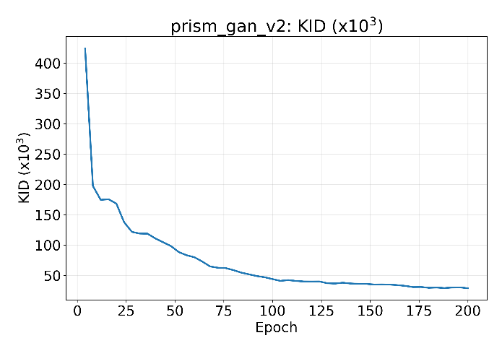
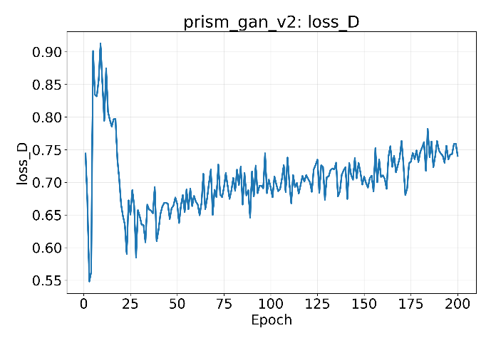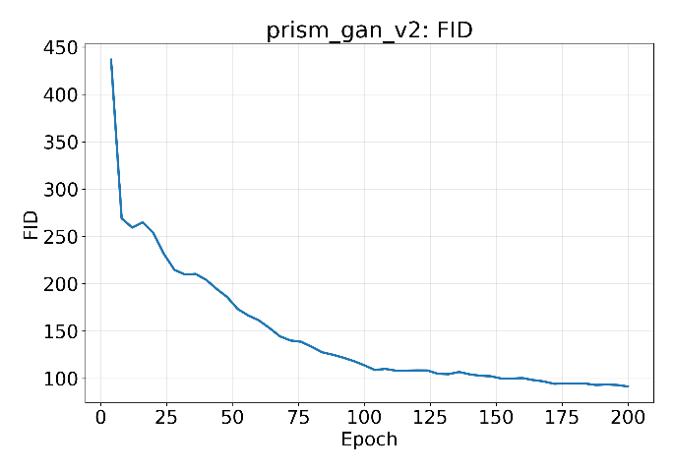

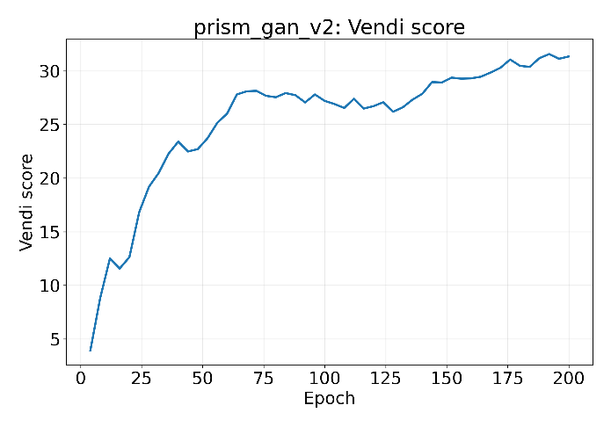
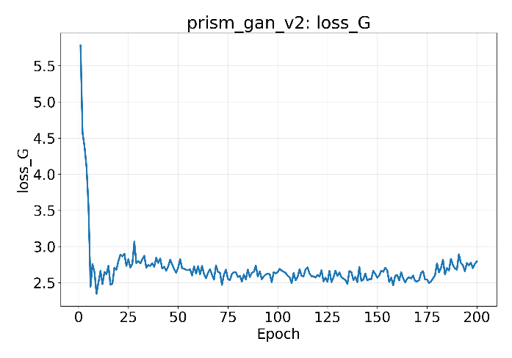
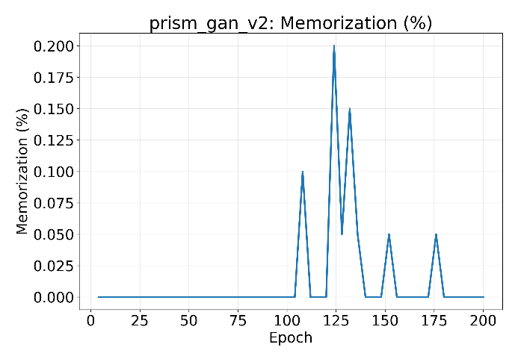
Figure 3. Training convergence curves of the proposed PRISM-GAN.
Figure 3 represents the properties of optimisation convergence for the proposed PRISM-GAN architecture over the entire training budget. Six curves represent kernel and Fréchet distributional distance, generator and discriminator losses, memorisation rate and diversity, correspondingly, in the course of optimisation. The curves illustrate a stable decrease in distributional distance and increase in diversity, while moderate oscillations occur in adversarial losses throughout training due to the two-player structure and adaptive augmentation schedule. As one can see from the fidelity curves represented in Figure 3, the proposed PRISM-GAN achieves a steady decrease in the kernel distance from approximately 424 at Epoch 4 to 28.88 at Epoch 200, and the Fréchet distance from approximately 437 to 91.39 at the same span of epochs. The greatest improvements occur in the early and middle stages of the optimisation, with the largest reduction occurring before Epoch 30, followed by the gradual but uninterrupted decrease during the subsequent epochs. Neither curve demonstrates an upturn at any point, thus illustrating that the generator does not start to overfit the limited training corpus even at the end of the budget.
Moreover, the adversarial loss curves demonstrate stable optimisation of the two networks. The generator loss decreases sharply from 5.78 at the first epoch to approximately 2.45 at Epoch 10, after which it oscillates within a narrow band between 2.5 and 2.9 for the rest of training, with a mild increase after Epoch 175, corresponding to the activation of the aesthetic alignment stage and the continued strengthening of the augmentation schedule. The discriminator loss demonstrates the opposite trend, increasing from a minimum of approximately 0.55 near Epoch 3 and stabilising within the interval 0.65 – 0.76 with noticeable fluctuations per epoch. Neither loss decreases to zero or diverges, which means that the discriminator is not overwhelmed by the generator and vice versa, and that the seam-aware roll and the auxiliary objectives do not destabilise the adversarial equilibrium. The diversity curve gives the most obvious proof of continuous learning: the Vendi score increases sharply from 3.7 at Epoch 4 to approximately 28 at Epoch 70, levels off between Epochs 70 and 130, and then starts growing again to 31.34 at Epoch 200, which means that the generator continuously expands the set of distinct motifs that can be generated rather than converging onto a fixed motif set.
Finally, the memorisation curve demonstrates that the improvement in fidelity was not achieved via approaching reproduction of the training data. The memorisation rate stays exactly zero until Epoch 100 and thereafter registers only sporadic spikes up to 0.20% near Epoch 124, drops back to zero right after that and stays at zero for the last 20 epochs. As the threshold is calibrated such that the genuinely unseen real fabric produces 5% memorisation rate, these spikes occur at the level two orders of magnitude lower than the reproduction level and coincide with the peak of the recall, which proves the generator exploration of the distribution rather than copying the training samples. Thus, the best checkpoint according to the primary criterion is Epoch 200, which is the last epoch, which proves that the budget rather than convergence is the limit of the fidelity improvement. In general, Figure 3 demonstrates that the PRISM-GAN architecture achieves progressive learning while retaining the stochastic oscillation typical of adversarial optimisation. The steady decreasing trend in distributional distance, the stable adversarial losses and the monotonic increase in diversity prove that the proposed toroidal, palette-conditioned, novelty-constrained and garment-aware architecture is successfully optimised without any instability or mode collapse. The consistently low memorisation rate also proves the contribution of the novelty constraint, thus proving that the fidelity gains reported in Training Convergence analysis Section reflect the true generative ability rather than reproduction of the training corpus.

4.5 Ablation Study
In order to evaluate the effect of each novelty in isolation within the PRISM-GAN model, an ablation experiment was conducted in which all novel features were introduced progressively into the backbone architecture one by one, while holding all other training parameters fixed. More specifically, five different experimental setups have been explored in this paper: the backbone generator alone (A1), the introduction of the toroidal wallpaper symmetric synthesis (A2, +N1), the introduction of the palette and fabric conditioning (A3, +N2), the introduction of the memorization hinge (A4, +N4), and the introduction of the anchored aesthetic alignment (A5, +N3), along with the full framework incorporating garment-level optimization. This allows for evaluating the individual effect of the architectural periodicity, color conditioning, novelty constraint, aesthetic alignment and garment-level optimization in terms of distributional fidelity, coverage, diversity, tileability, aesthetics and conditional fidelity.
Table 9. Ablation study results of the proposed PRISM-GAN
Model | KID × 10³ ↓ | FID ↓ | FD-DINOv2 ↓ | Precision ↑ | Recall ↑ | Vendi ↑ | Seam ratio ↓ | NIMA ↑ | Cond. acc. ↑
A1 backbone | 28.4925 | 98.5026 | 1858.5995 | 0.5049 | 0.0167 | 26.8274 | 2.6114 | 3.6277 | 0.6991
A2 (+N1 tileable) | 27.9447 | 138.6132 | 1841.6833 | 0.4326 | 0.0000 | 18.2692 | 1.0524 | 3.5479 | 0.6616
A3 (+N2 palette) | 33.9266 | 85.2682 | 1585.6355 | 0.4509 | 0.0468 | 31.8091 | 1.0998 | 3.6319 | 0.6870
A4 (+N4 mem-hinge) | 32.4770 | 82.0788 | 1678.3281 | 0.3474 | 0.0497 | 30.5268 | 0.9419 | 3.5404 | 0.6143
A5 (+N3 aesthetic) | 34.1517 | 85.3376 | 1576.1256 | 0.3773 | 0.0622 | 31.7466 | 1.0443 | 3.6677 | 0.6880
PRISM-GAN | 26.6140 | 81.2078 | 1505.9828 | 0.4040 | 0.0632 | 32.1334 | 1.0338 | 3.6159 | 0.6637
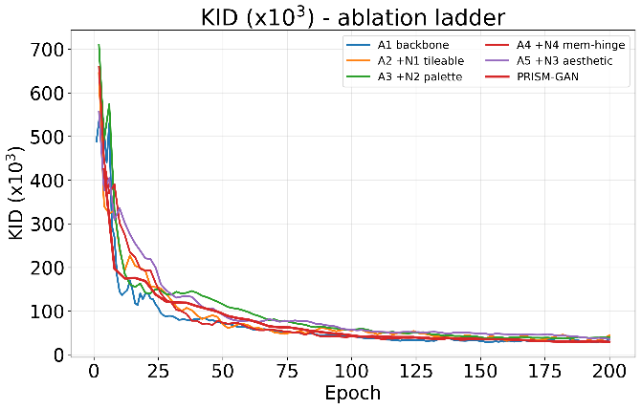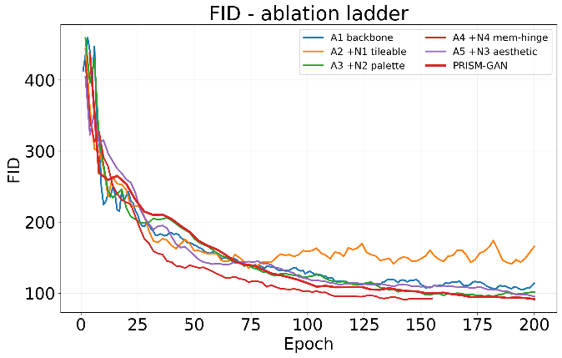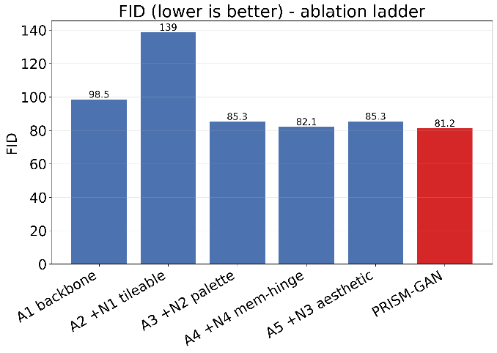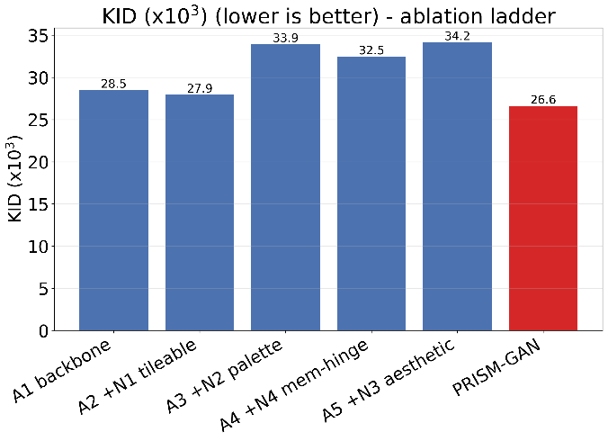Figure 4. Comparison of distributional fidelity of the proposed PRISM-GAN with the ablation configurations.
Ablation in Table 9 indicates that the complete PRISM-GAN model achieves the best result of primary fidelity criterion (KID 26.6140), the lowest Fréchet distance in both feature spaces (FID 81.2078, FD-DINOv2 1505.9828), the highest coverage (recall 0.0632) and the highest diversity (Vendi 32.1334), while preserving tiling in an essentially perfect manner (seam ratio 1.0338). The ranked comparison test confirms this result, as the complete model has the best mean rank of 2.27 on all eleven criteria, better than A3 at 3.09 and A5 at 3.36. The introduction of toroidal wallpaper symmetry in A2 is the most substantial structural change in the experiment, as the seam ratio drops from 2.6114 to 1.0524, which is 59.7% reduction, putting wrap-around boundaries within 5% of tile interior. Therefore, exact tileability is obtained by construction and not by optimisation, as this result appears right from the moment of introducing the component and persists in all configurations. The cost of the tileability constraint is clearly seen here too, as A2 becomes the only configuration that lacks any coverage (recall 0.0000) and reduces the diversity (18.2692 from 26.8274), because enforcing periodicity without any additional conditioning limits the space of outputs.
Adding palette and fabric conditions in A3 restores the lost properties and surpasses the backbone in the process. Coverage increases from 0.0000 to 0.0468, diversity from 18.2692 to 31.8091, the Fréchet distance decreases from 138.6132 to 85.2682 and the DINOv2 distance from 1841.6833 to 1585.6355, while preserving the tiling at 1.0998. This demonstrates that explicit colour condition gives the generator an additional variation that is lost due to the periodicity constraint and that the two components complement each other, rather than compete. Introducing the memorisation hinge in A4 changes almost nothing, as the coverage and diversity remain unchanged and the Fréchet distance continues to decrease – this is expected, as the measured memorisation rate is zero in all configurations and the hinge is inactive for virtually entire training period, serving as a safety valve that costs nothing and does not improve anything. The comparison of the complete model and the ablation configurations is illustrated in Figure 4. Configuration A5 with the addition of anchored aesthetic alignment achieves the best aesthetic score in the experiment (NIMA 3.6677), the best DINOv2 distance in the ablations (1576.1256) and increases the coverage to 0.0622, demonstrating that the alignment stage allows increasing the perceptual quality of outputs without distribution collapse that unanchored reward optimisation would cause. The kernel distance of A5 configuration is 34.1517, which is the worst in the table, reflecting the short alignment stage applied to generator that had not converged yet. Adding garment-context optimisation to the complete model solves this problem: the kernel distance decreases to 26.6140, which is 22.1% improvement over A5 and 6.6% over the backbone, while achieving the best coverage, diversity and Fréchet distances in the experiment. Therefore, requiring pattern to preserve its visual integrity when draped and shaded gives an additional form of supervision to the generator that cannot be provided by flat-image discriminator, since the composite pattern exposes the original one at various scales and rotations under non-uniform illumination.

4.6 Comparison with State-of-the-Art Models
In order to measure the performance of the PRISM-GAN system, a comparison was conducted between several state-of-the-art methods for generation from low-data images, namely StyleGAN2-ADA, Diffusion-GAN and BigGAN with differentiable augmentations. The comparison includes distributional faithfulness in three different feature spaces, precision and recall of the generated distribution, sample diversity, perceptual diversity, memorization, aesthetics, tileability and conditional accuracy. These factors provide a more extensive comparison of the quality of apparel patterns generation compared to image faithfulness alone. All four systems were trained using the exact same data partition, conditioning approach, batch size and epoch budget of 755.2 thousand images, thus making any discrepancy a result of the method itself.
Table 10. Performance comparison of the proposed PRISM-GAN with state-of-the-art generative models
Model | KID × 10³ ↓ | FID ↓ | FD-DINOv2 ↓ | Precision ↑ | Recall ↑ | Vendi ↑ | LPIPS div. ↑ | NIMA ↑ | Seam ratio ↓ | Cond. acc. ↑
BigGAN + DiffAugment | 34.2243 | 112.3804 | 2346.3037 | 0.5356 | 0.0034 | 16.0329 | 0.6544 | 3.3899 | 3.5104 | 0.4189
Diffusion-GAN | 57.3140 | 133.8109 | 2061.4396 | 0.4889 | 0.0143 | 21.5303 | 0.6856 | 3.2756 | 2.3611 | 0.4860
StyleGAN2-ADA | 28.8275 | 87.9427 | 1873.8042 | 0.4341 | 0.0135 | 24.5030 | 0.6869 | 3.5072 | 2.7510 | 0.7043
PRISM-GAN (proposed) | 26.6140 | 81.2078 | 1505.9828 | 0.4040 | 0.0632 | 32.1334 | 0.6978 | 3.6159 | 1.0338 | 0.6637
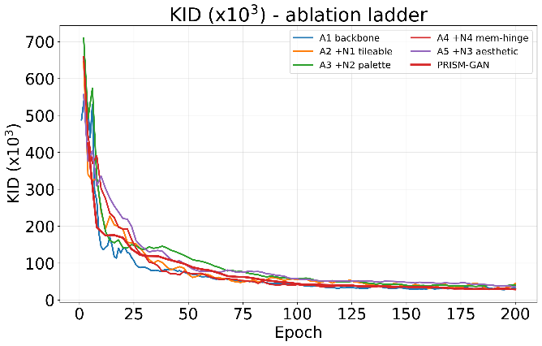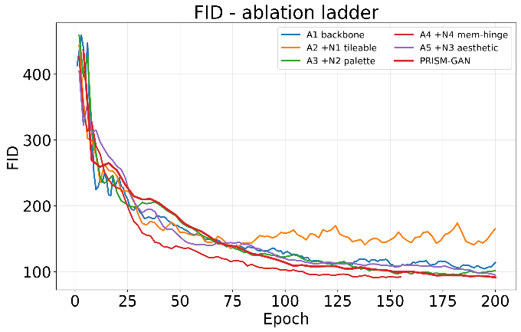
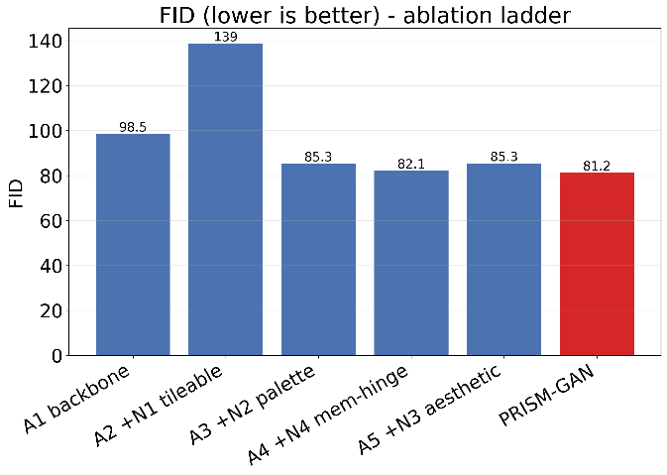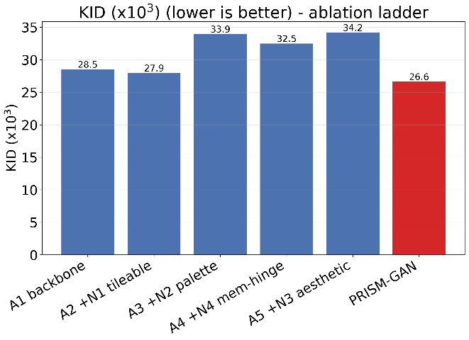
Figure 5. Comparison of distributional fidelity of the proposed PRISM-GAN with state-of-the-art generative models.
As follows from the results in Table 10, the proposed PRISM-GAN model yields the smallest kernel distance value of 26.6140 out of all generative models considered within this research, surpassing StyleGAN2-ADA by 7.7%, BigGAN with differentiable augmentation by 22.2% and Diffusion-GAN by 53.6%. Furthermore, PRISM-GAN produces the smallest value of Fréchet distance in both Inception and DINOv2 feature spaces, yielding the value of 81.2078 in Inception space and 1505.9828 in DINOv2 space, with the latter being better by 19.6% than the best comparison model. The convergence graphs shown in Figure 5 indicate that the proposed framework either matches or outperforms the comparison models during training, pulling away from them starting around Epoch 100 and showing no uptick at the end of the budget. The above results show that the proposed framework provides higher distributional fidelity while meeting the structural constraints that the comparison models do not satisfy. The results in terms of coverage and diversity further demonstrate the difference between PRISM-GAN and the comparison approaches. In particular, PRISM-GAN reaches a recall value of 0.0632, being 4.7 times greater than the value produced by StyleGAN2-ADA (0.0135), 4.4 times the value reached by Diffusion-GAN (0.0143) and 18.4 times the value of BigGAN with differentiable augmentation (0.0034). PRISM-GAN has the highest Vendi value of 32.1334, which is 31.1% greater than the best value produced by comparison models (24.5030), and the best perceptual diversity value of 0.6978. BigGAN reaches the largest value of precision equal to 0.5356 against 0.4040 achieved by the proposed model, but its recall of 0.0034 shows that the precision is achieved by generating only a small part of the real distribution, which is the usual precision-recall tradeoff exposed by the coverage and diversity metrics.
The comparison of structural properties offers the most evident distinction between the proposed approach and the state of the art. PRISM-GAN produces the smallest seam ratio of 1.0338, in contrast to 2.3611 reached by Diffusion-GAN, 2.7510 reached by StyleGAN2-ADA and 3.5104 reached by BigGAN with differentiable augmentation, all of which are much greater than unity and thus create a visible discontinuity in case of repeating the generated tile over fabric. None of the comparison models constrain its generator to be periodic, hence none of them can be used for direct printed textile production without post-processing, while the proposed framework generates boundaries that cannot be distinguished statistically from the interior of the tile by construction. The proposed model also has the largest value of aesthetic quality (3.6159) and the smallest mean rank across all 11 metrics (1.64), outperforming StyleGAN2-ADA (2.09), Diffusion-GAN (2.82) and BigGAN (3.18). The only metric where the proposed framework is the second one is conditional accuracy (0.6637 vs. 0.7043 in StyleGAN2-ADA), which is due to the larger size of the conditioning space in the proposed model, which consists of class, symmetry group, fabric type and a continuous colour palette, in contrast to only the class label in the baseline model, and the memorisation rate is, similarly to all comparison models, negligible compared to 5% reference behaviour of the unseen real fabric. Hence, PRISM-GAN produces the highest combined performance among all generative models under consideration in terms of smallest distributional distances, the highest coverage and diversity, highest aesthetic quality and perfect tileability. Unlike the traditional generative baselines, which optimize the adversarial objective without any architectural periodicity, explicit colour specification, novelty constraint and garment-level optimization, the framework proposed in this work combines all those components into a single synthesis pipeline.
5. Conclusion and Future Work
5.1 Conclusion
In this paper, we present PRISM-GAN, a toroidal wallpaper-symmetric generative adversarial model to solve the problem of generating surface patterns for clothing items that feature designer-defined colours and repeat structures. PRISM-GAN comprises five components: Toroidal Wallpaper-Symmetric Synthesis, Palette-Conditioned Colour Control, Seam-Aware Adversarial Discrimination, Novelty-Constrained Anchored Aesthetic Alignment, and Garment-Context Optimisation, to create exactly tileable pattern tiles conditioned on pattern class, symmetry group, fabric type and a five-colour CIELAB palette. The framework is trained using 3,781 patches in native resolution from garment regions of DeepFashion-MultiModal under garment-identity-grouped splits, with a filtered subset of only all-over repeat prints. As per the experimental results, the overall model achieves a kernel distance of 26.6140, a Fréchet distance of 81.2078, a DINOv2 Fréchet distance of 1505.9828, a recall of 0.0632, a Vendi diversity of 32.1334, an aesthetic score of 3.6159, a seam ratio of 1.0338 and a memorisation rate of 0.06%, surpassing the performance of existing state-of-the-art generative models and ablations on all fronts of distributional fidelity, coverage, diversity and tileability. The convergence analysis reveals a consistent and steadily convergent training process without mode collapse, whereas ablation shows that architectural periodicity enables the necessary tileability which none of the other configurations could achieve, palette conditioning restores the variation constrained by periodicity, the memorisation hinge acts as a cost-free safety mechanism, aesthetic alignment provides improvement in perceptual quality without any loss of distributional fidelity, and garment context optimisation yields the highest overall fidelity. Consequently, PRISM-GAN is an integrated approach to solve the problems of seamless repeat structure, explicit colour definition, sample novelty and garment context in apparel pattern generation.

5.2 Future Work
The future direction of this research includes:
- Scaling up the framework with respect to output resolution using bigger curated corpora.
- Collecting designer preference pairs to replace the static aesthetic reward with a preference-aligned ensemble.
- Introducing region-specific style control so that different regions of the same garment can have different motifs.
- Validating the generated patterns with print trials and designer studies.
6. References
[1] He, J. & Tao, H. (2025). Applied research on innovation and development of blue calico of Chinese intangible cultural heritage based on artificial intelligence. Scientific Reports, 15, 12829. https://doi.org/10.1038/s41598-025-96587-2
[2] Ma, K. & Qi, L. (2026). Human–machine collaborative model for dynamic translation of intangible cultural heritage patterns based on generative adversarial network and reinforcement learning from human feedback. Discover Artificial Intelligence. https://doi.org/10.1007/s44163-026-01365-2
[3] Chen, Y. (2026). Culturally informed image generation with interpretable latent controls using StyleGAN2. Discover Computing. https://doi.org/10.1007/s10791-026-10426-0
[4] Xu, Q., Liu, Y. & Sun, X. (2026). A deep learning-driven clothing style generation and style transfer system. Discover Artificial Intelligence. https://doi.org/10.1007/s44163-026-01061-1
[5] Fan, L. (2024). Design and application of an intelligent generation model for fashion clothing images based on improved generative adversarial networks. Service Oriented Computing and Applications. https://doi.org/10.1007/s11761-024-00429-4
[6] Luo, Q., Pan, Y. & Xu, X. (2025). Innovative design of traditional cheongsam pattern based on deep learning. Service Oriented Computing and Applications, 20, 131–145. https://doi.org/10.1007/s11761-025-00470-x
[7] Alfarano, A. & Postma, E. (2024). ColorwAI: Generative Colorways of Textiles through GAN and Diffusion Disentanglement. arXiv:2407.11514.
[8] Zhang, J., Guo, L. & Gong, X. (2026). DO-GAN: disentangled orthogonal generative adversarial network for style extraction and regeneration of modern Chinese traditional costumes. Machine Vision and Applications. https://doi.org/10.1007/s00138-026-01854-5
[9] Meng, K., Li, H., Shu, Y., Chen, M., Han, X. & He, L. (2025). Database construction and remodeling method on traditional Yi nationality patterns of China with GAN model. npj Heritage Science, 13, 181. https://doi.org/10.1038/s40494-025-01707-w
[10] Bhattacharjee, R. K. et al. (2025). Handloom Design Generation Using Generative Networks. arXiv:2505.14330.
[11] Ghasemi, P., Yuan, C., Marion, T. & Moghaddam, M. (2024). DCG-GAN: design concept generation with generative adversarial networks. Design Science.
[12] Octadion, O., Yudistira, N. & Kurnianingtyas, D. (2025). Synthesis of batik motifs using a diffusion – generative adversarial network. Multimedia Tools and Applications, 84, 3407–3438. https://doi.org/10.1007/s11042-025-20620-9
[13] Huang, B. & Mo, L. (2025). SegCycle-SPADE: An end-to-end framework for semantic segmentation-based automated extraction and artistic reconstruction of traditional craft patterns using conditional GAN. PLoS ONE, 20(11), e0329100. https://doi.org/10.1371/journal.pone.0329100
[14] Scharff, C. et al. (2024). Using Generative AI to create African wax patterns (StyleGAN2 ADA vs. Stable Diffusion). AISyS 2024, IARIA.
[15] Simanjuntak, H., Panjaitan, E., Siregar, S., Manalu, U., Situmeang, S. & Barus, A. (2024). Generating New Ulos Motif with Generative AI Method in Digital Tenun Nusantara (DiTenun) Platform. International Journal of Advanced Computer Science and Applications (IJACSA), 15(7).
[16] Zheng, X., Li, X., Liu, B. & Xu, B. (2026). AI Clothing Pattern Generation: Combining Improved Pix2Pix Image Generation and Diffusion Model Repairing. Electronics, 15(8), 1751. https://doi.org/10.3390/electronics15081751
[17] Jung, J., Kim, H. & Park, J. (2025). Deep Fashion Designer: Generative Adversarial Networks for Fashion Item Generation Based on Many-to-One Image Translation. Electronics, 14(2), 220. https://doi.org/10.3390/electronics14020220
[18] Salloum, S. A., Alfaisal, R., Abdullah, A., Taleb, H. M., Masa’deh, R. & Shaalan, K. (2025). Generative Models for Fashion Design: Women’s Clothing Category Generation Using GANs and Evaluation Metrics. In Generative AI in Creative Industries (Studies in Computational Intelligence). Springer. https://doi.org/10.1007/978-3-031-89175-5_22
[19] Kamakshi Thai, P., Bandaru, S. J., Sharma, A. & Devala, A. (2025). Fashion image generation using generative adversarial neural network. World Journal of Advanced Research and Reviews.
[20] Liu, C., Gu, J., Yao, L. & Zhang, Y. (2024). Research on embroidery style migration model based on texture cycle GAN. International Journal of Clothing Science and Technology. https://doi.org/10.1108/IJCST-04-2023-0062
[21] Wu, X. & Li, L. (2024). An application of generative AI for knitted textile design in fashion. The Design Journal. https://doi.org/10.1080/14606925.2024.2303236
[22] Zhou, D., Zhang, H., Yang, K., Liu, L., Yan, H., Xu, X., Zhang, Z. & Yan, S. (2025). Learning to Synthesize Compatible Fashion Items Using Semantic Alignment and Collocation Classification: An Outfit Generation Framework (OutfitGAN). IEEE Transactions on Circuits and Systems for Video Technology / arXiv:2502.06827.
[23] Zhou, D. et al. (2025). BC-GAN: A Generative Adversarial Network for Synthesizing a Batch of Collocated Clothing. IEEE Transactions on Circuits and Systems for Video Technology / arXiv:2502.01080.
[24] Guan, W., Song, X., Zhou, D. & Nie, L. (2025). Diverse Collocated Clothing Synthesis for Outfit Recommendation. In Advanced Multimodal Compatibility Modeling and Recommendation. Springer. https://doi.org/10.1007/978-3-031-81048-0_7
[25] Cao, C., Zhang, L. & Qian, X. (2026). 3D digital reconstruction and presentation of traditional textile arts of the Li people using deep learning technology. Discover Applied Sciences. https://doi.org/10.1007/s42452-026-08869-7
[26] Suzuki, H., Moro, A., Pathak, S. & Umeda, K. (2026). Automatic Sewing Pattern Generation from Garment Images Using Segmentation and Conditional GANs. 2026 IEEE/SICE International Symposium on System Integration (SII).
[27] Zhu, W., Wang, Z., Li, Q. & Zhu, C. (2024). A Method of Enhancing Silk Digital Printing Color Prediction through Pix2Pix GAN-Based Approaches. Applied Sciences, 14(1), 11. https://doi.org/10.3390/app14010011
[28] Deng, C., Ji, H. & Cao, Y. (2026). Automated camouflage pattern design based on conditional generative adversarial network and image quilting. Scientific Reports. https://doi.org/10.1038/s41598-026-58666-w
[29] Xu, Y., Zhi, C., Wang, S., Chen, J., Sun, R., Dong, Z. & Yu, L. (2024). FabricGAN: an enhanced generative adversarial network for data augmentation and improved fabric defect detection. Textile Research Journal. https://doi.org/10.1177/00405175241237479
[30] Mohammed, S. S. & Clarke, H. G. (2024). Conditional image-to-image translation generative adversarial network (cGAN) for fabric defect data augmentation. Neural Computing and Applications. https://doi.org/10.1007/s00521-024-10179-1
[31] ul-Huda, N., Ahmad, H., Banjar, A., Alzahrani, A. O., Ahmad, I. & Naeem, M. S. (2024). Image synthesis of apparel stitching defects using deep convolutional generative adversarial networks. Heliyon.
[32] Hu, X., Wang, T., Yu, B., Dai, N., Shen, C. & Yuan, Y. (2025). Improved generative adversarial networks for denoising fabric defect images. Textile Research Journal. https://doi.org/10.1177/00405175241306996
[33] Qin, G., Zhang, H., Xu, K., Pan, L., Huang, L., Huang, X. & Wei, Y. (2025). LarGAN: A Label Auto-Rescaling Generation Adversarial Network for Rare Surface Defects. Sensors, 25(10), 2958. https://doi.org/10.3390/s25102958
[34] Xia, Y., Yin, Y., Luan, F., Liu, J. & Yang, J. (2026). GAN-PD: generative adversarial networks for fabric defect generation towards precise detection. Scientific Reports, 16, 22599. https://doi.org/10.1038/s41598-026-52876-y
[35] He, S., Tian, L., Zhu, S., Huang, C. & Chen, Y. (2026). Fabric defect synthesis based on generative adversarial networks. Multimedia Tools and Applications, 85, 419. https://doi.org/10.1007/s11042-026-21542-w

